**0.9-5.5 PREDICTIONS**

**900 MHz, 15 (0.05 lambda)**

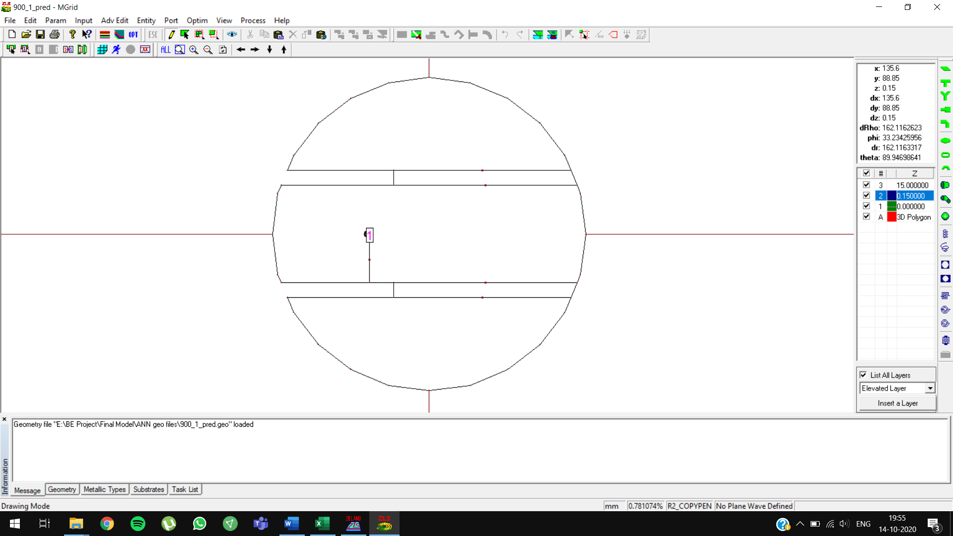

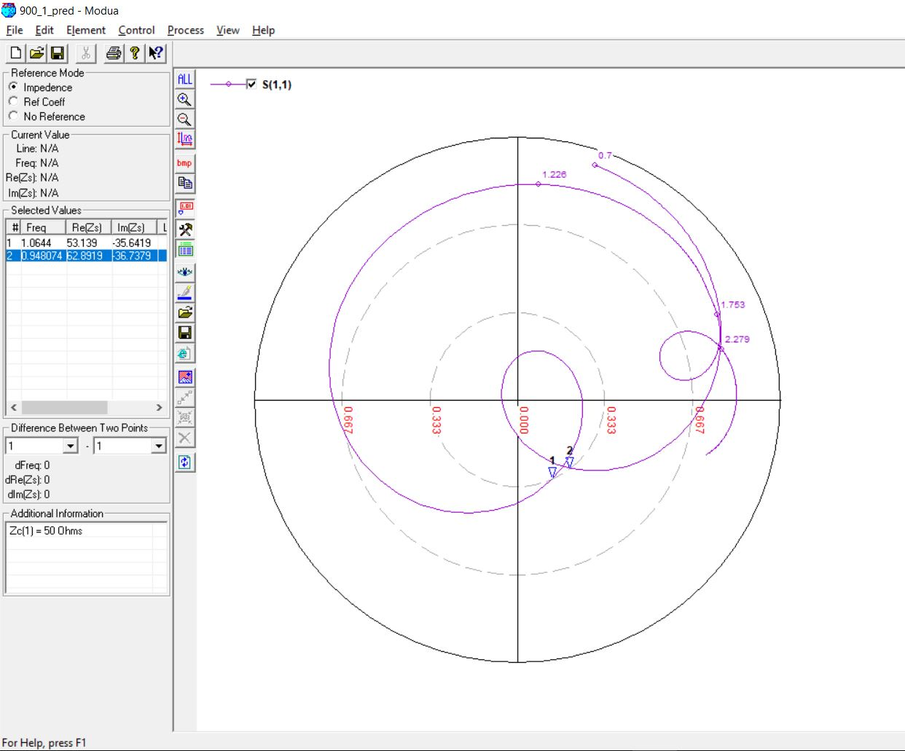

**900 MHz, 22 (0.07 lambda)**

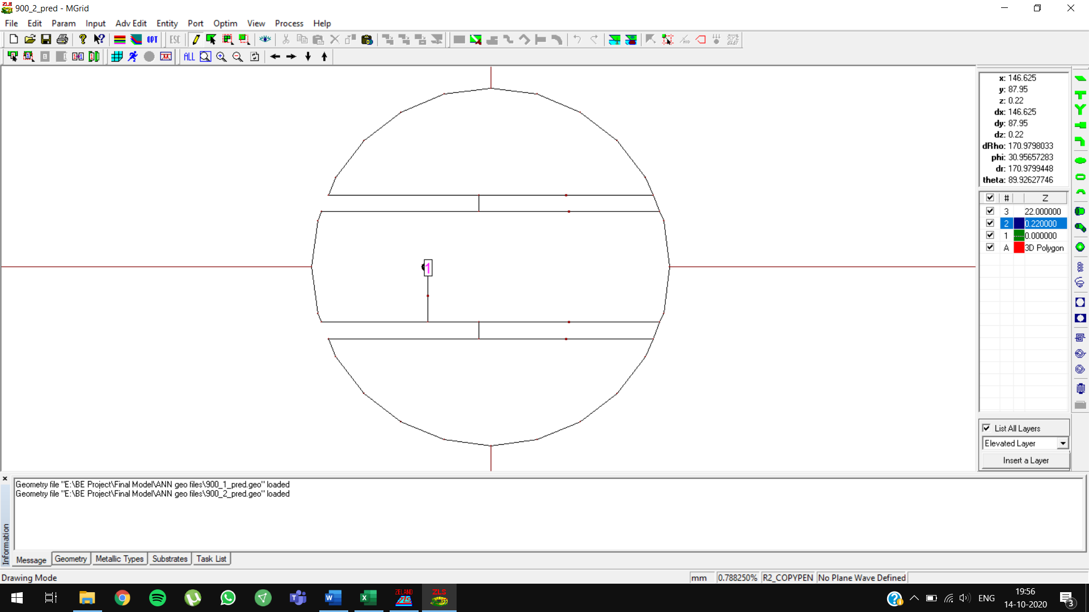

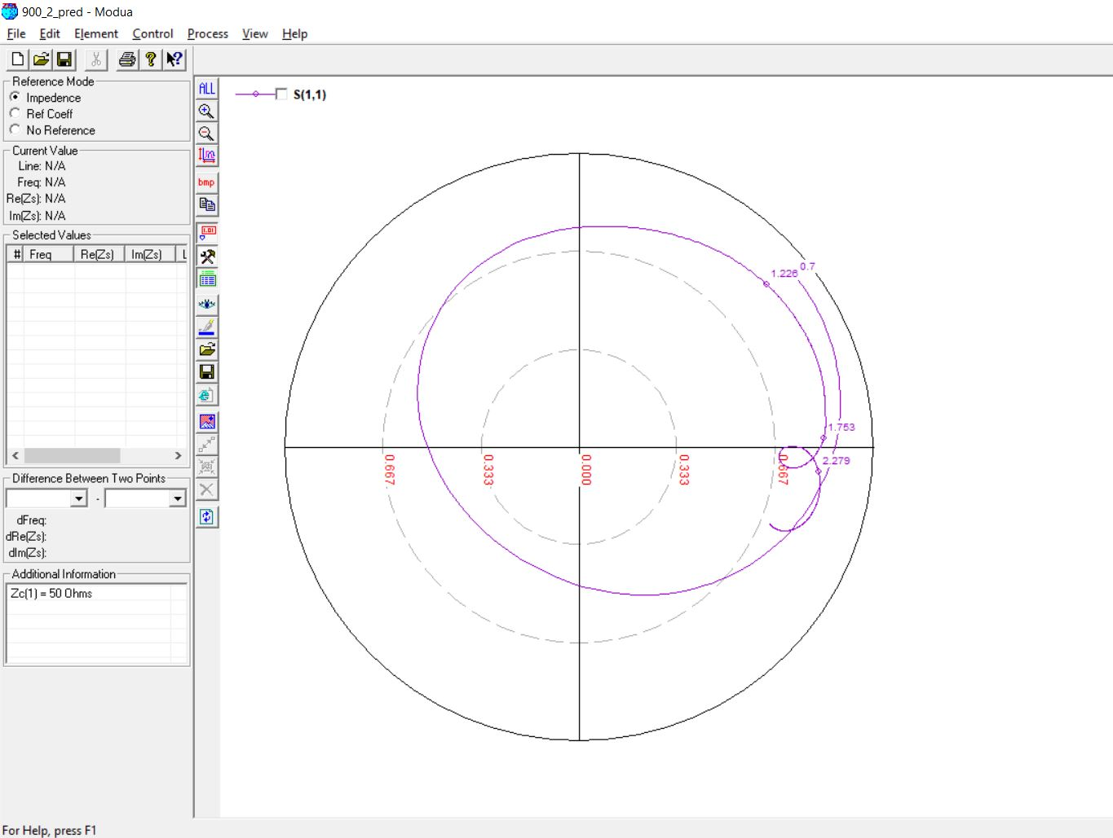

**1500 MHz, 10 (0.05 lambda)**

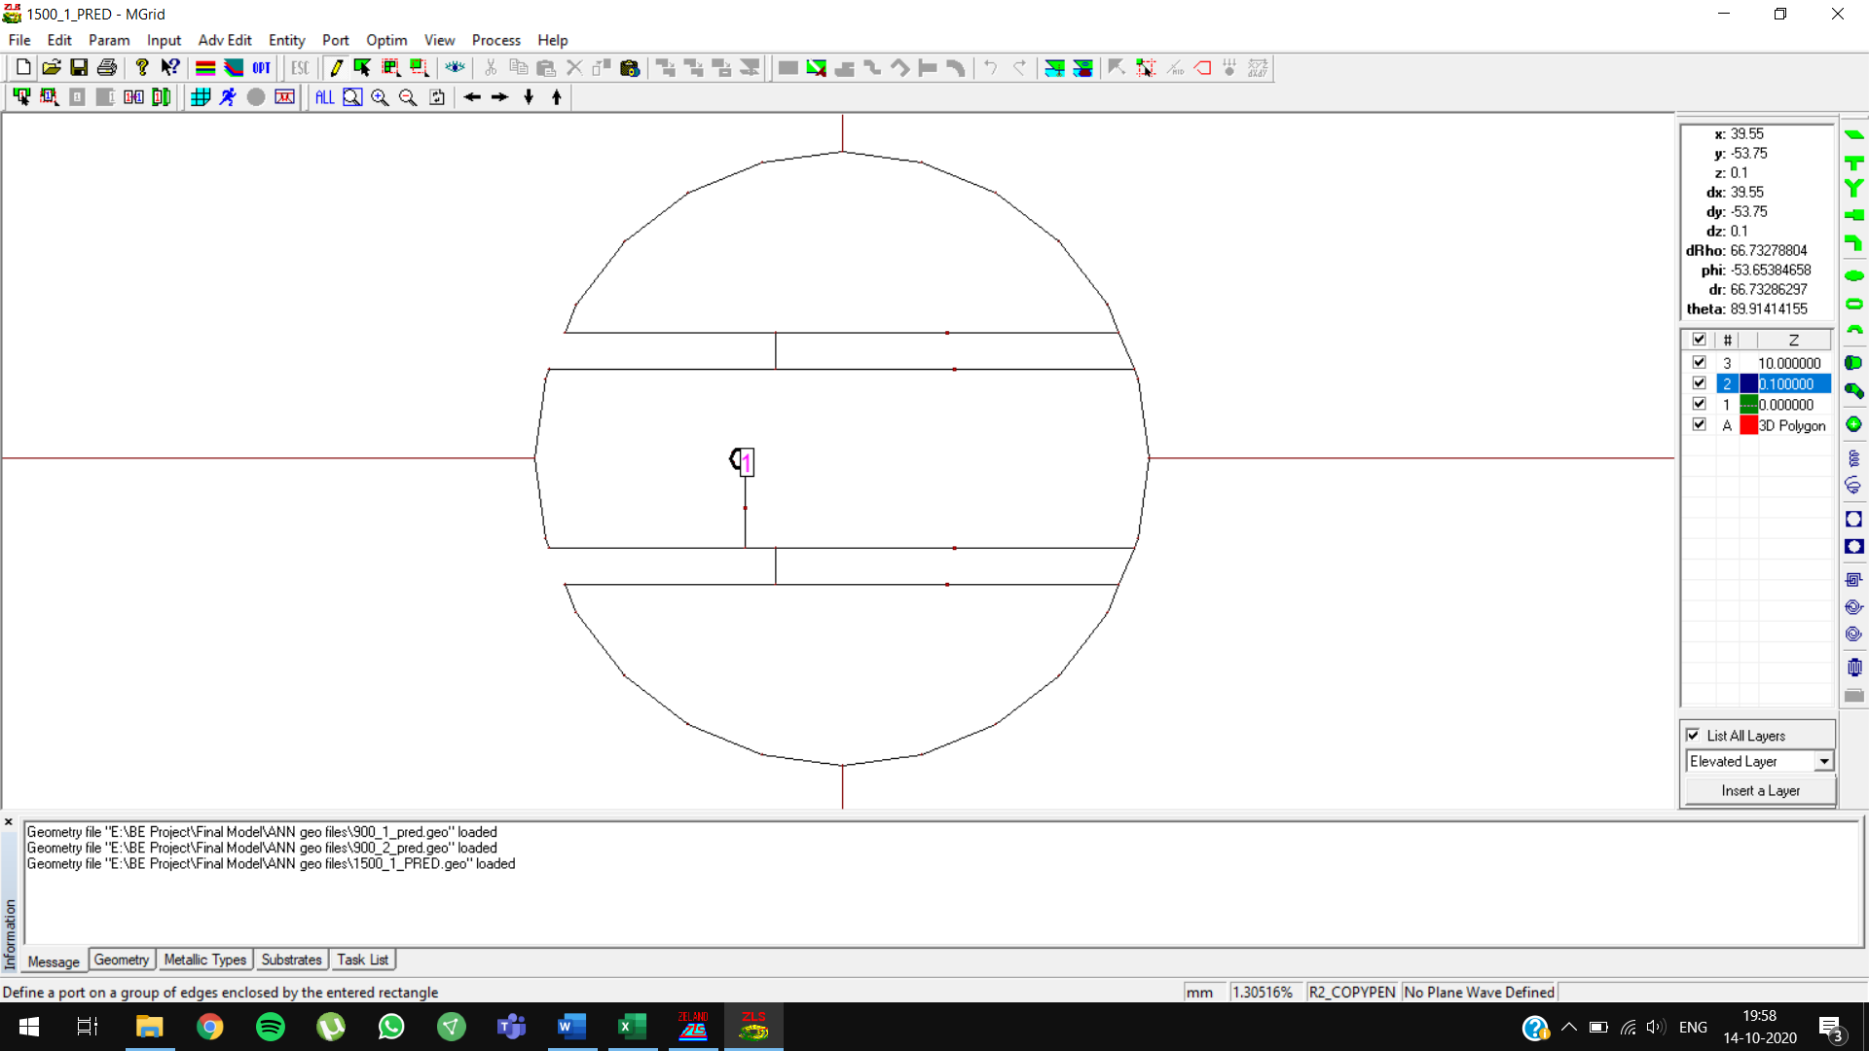

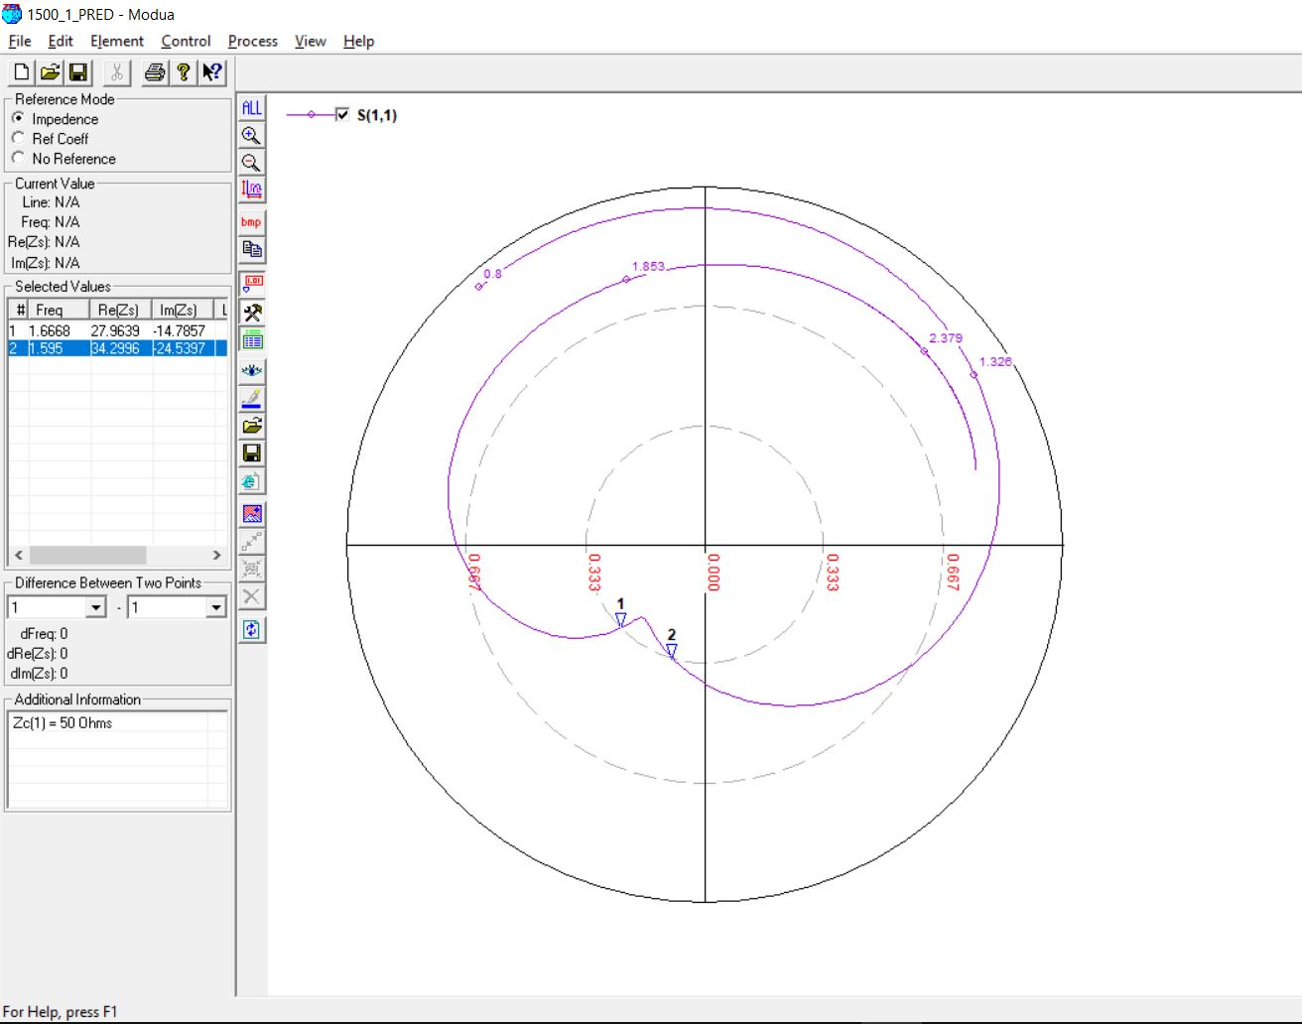

**1500 MHz, 10 (0.05 lambda) OPTIMIZED**

Initial Prediction: feed position = **-16.16**, Slot length = **39.8414 mm**

Optimized Prediction: feed position = **-16**, Slot length = **37.8414 mm**

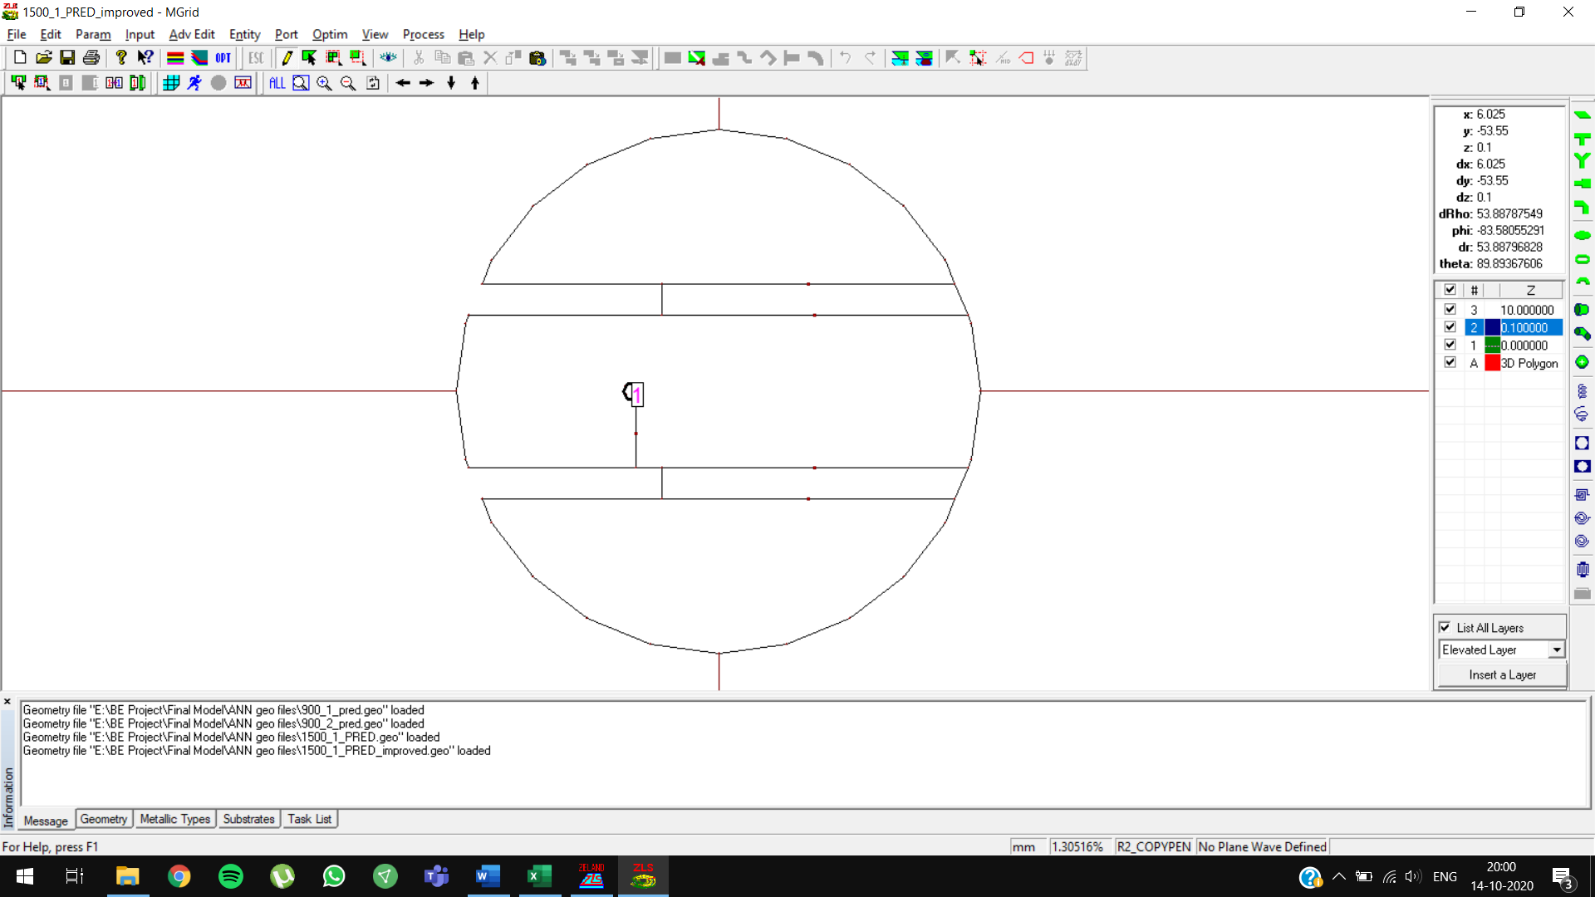

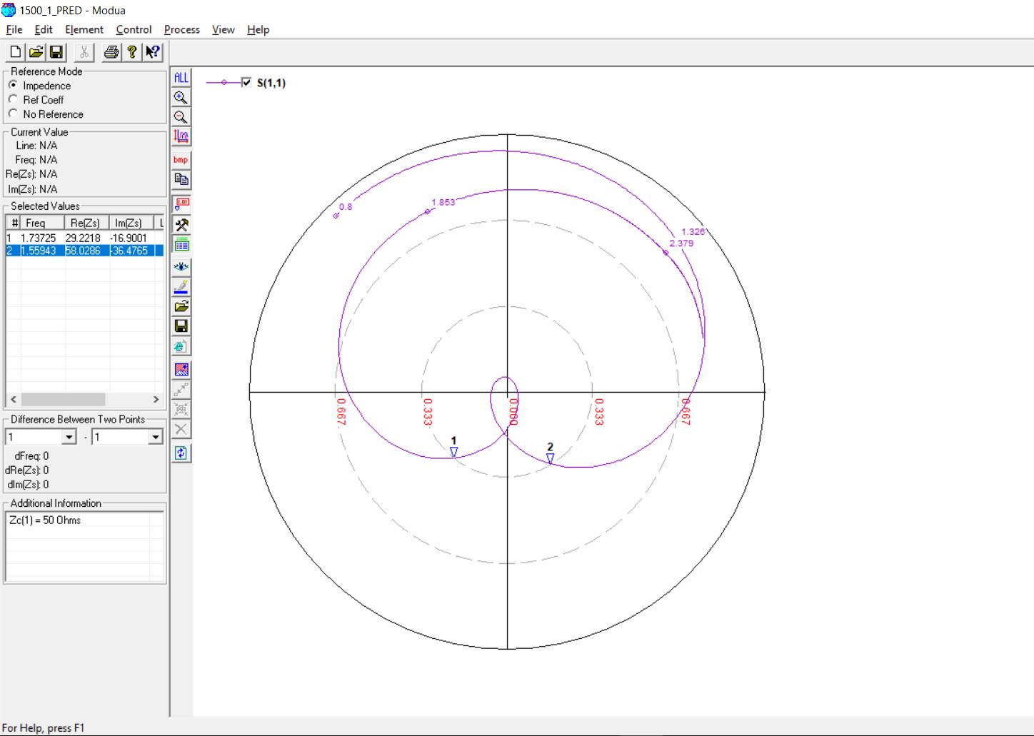

**1500 MHz, 14 (0.07 lambda)**

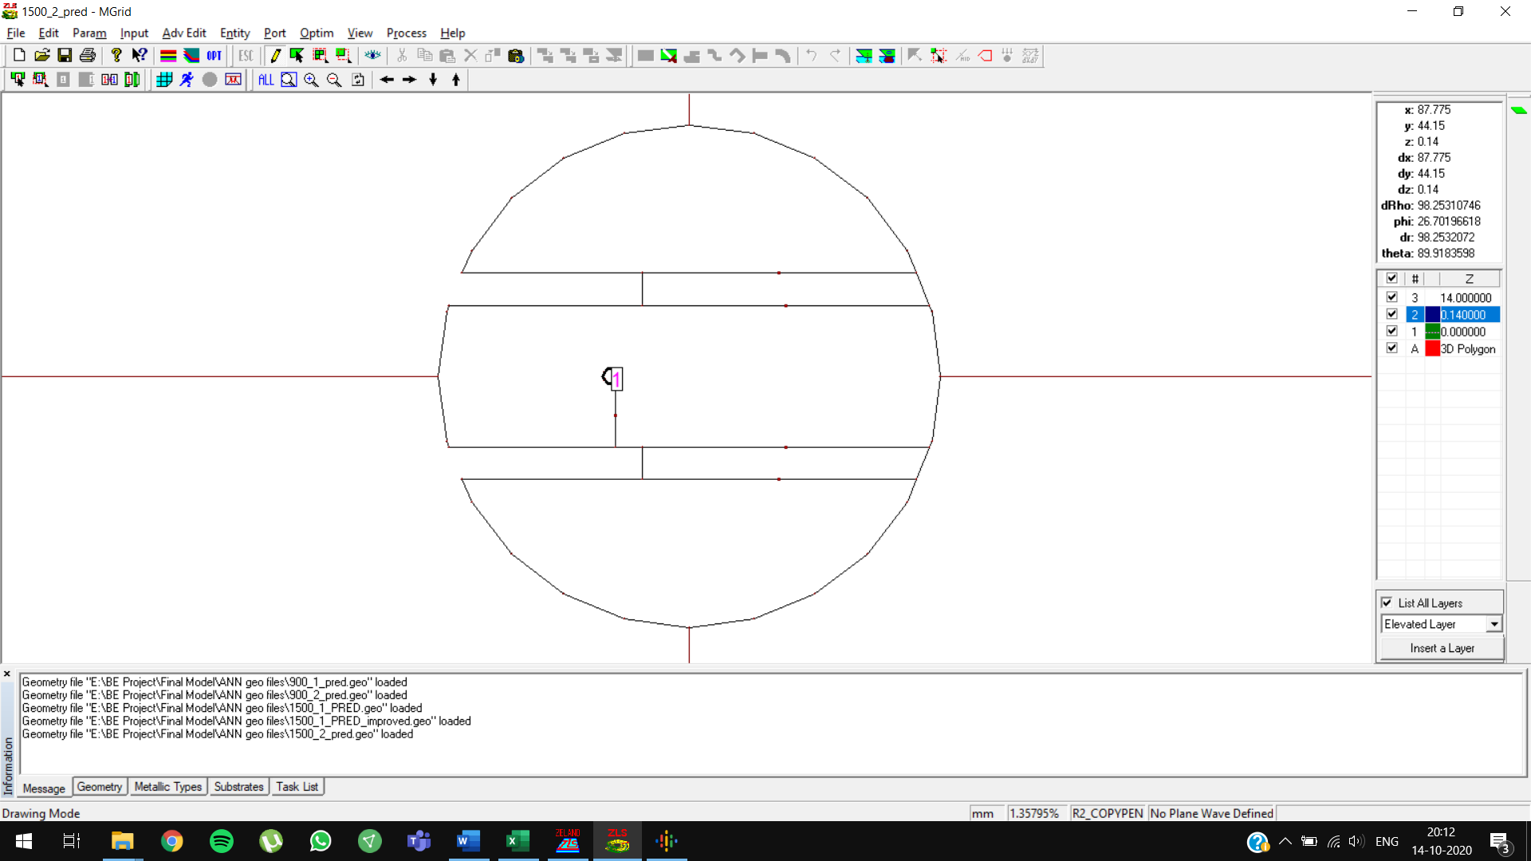

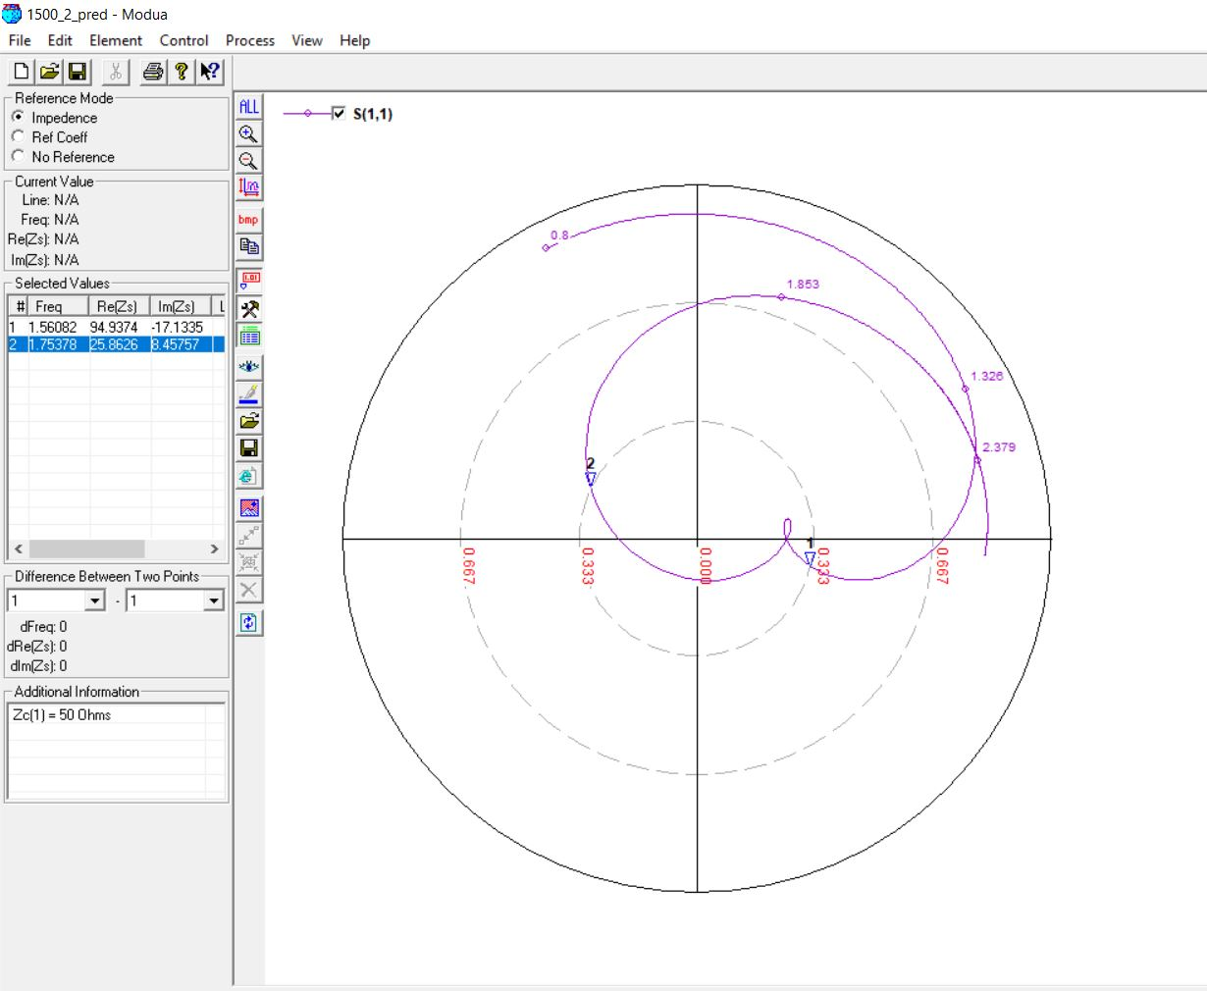

**2100 MHz, 8 (0.05 lambda)**

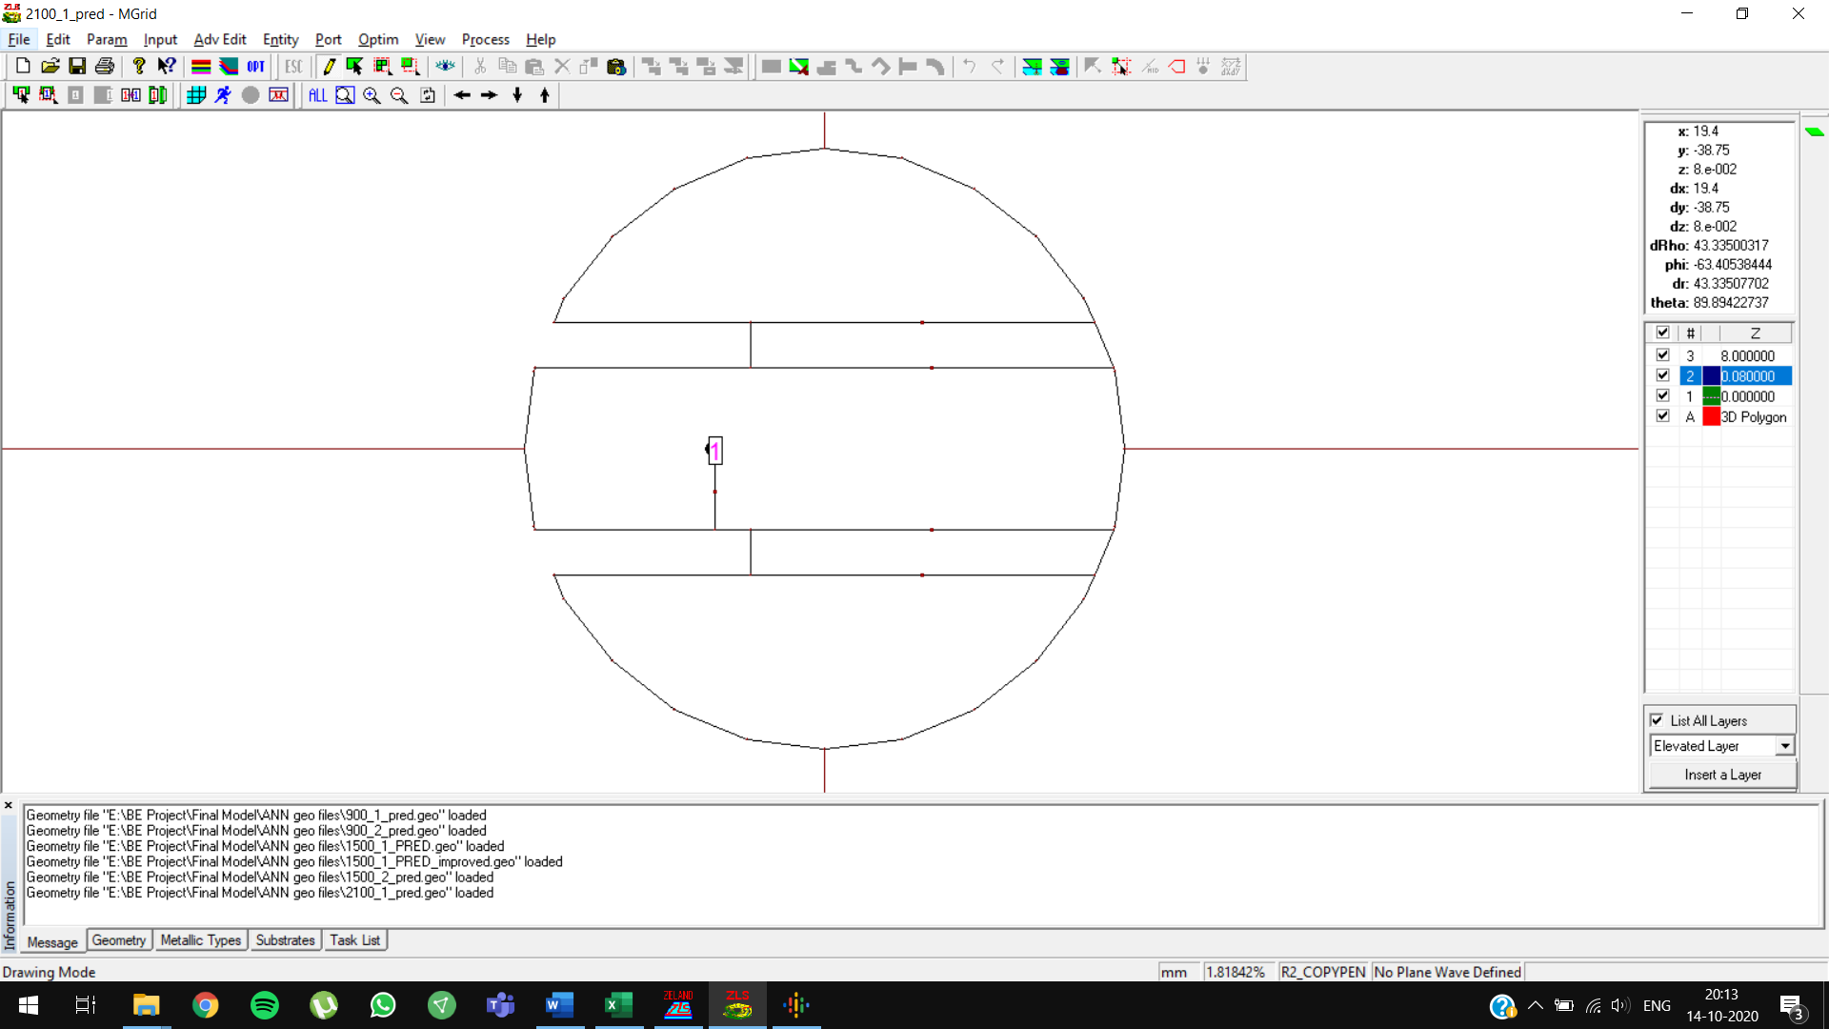

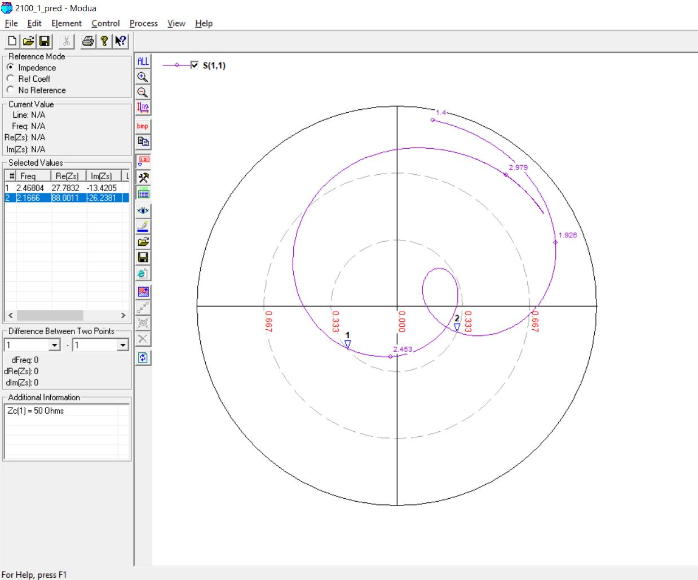

**2100 MHz, 8 (0.05 lambda) OPTIMIZED**

Initial Prediction: feed position = **-12.9823**, Slot length = **26.146 mm**

Optimized Prediction: feed position = **-11.9823**, Slot length = **27.146 mm**

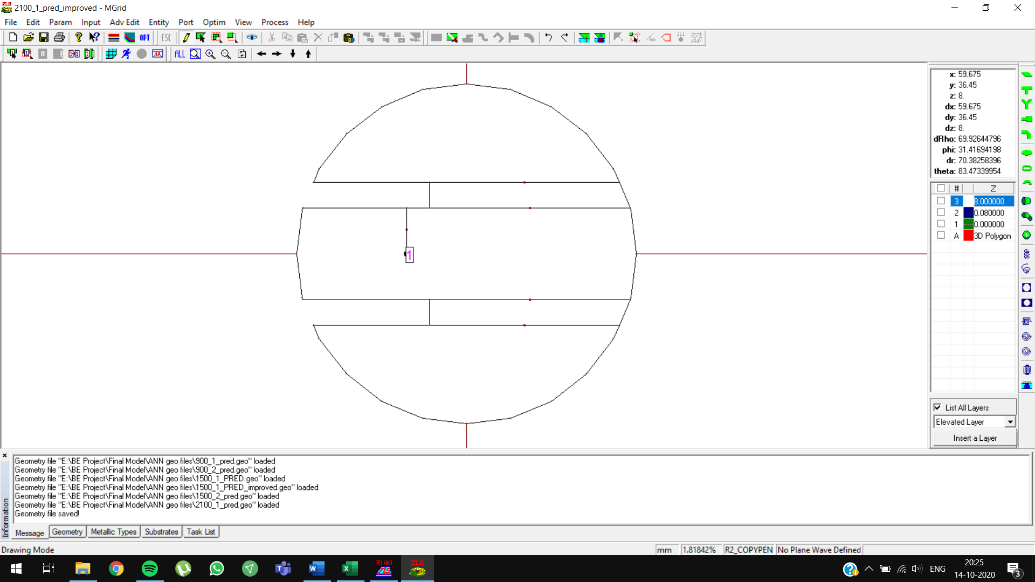

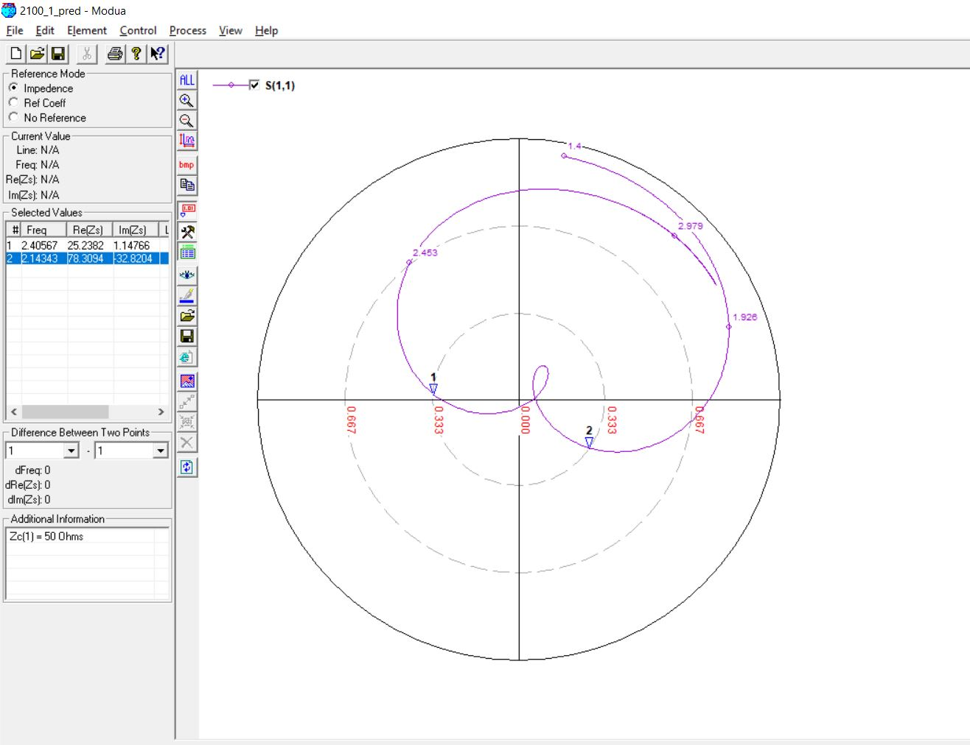

**2100 MHz, 9 (0.07 lambda)**

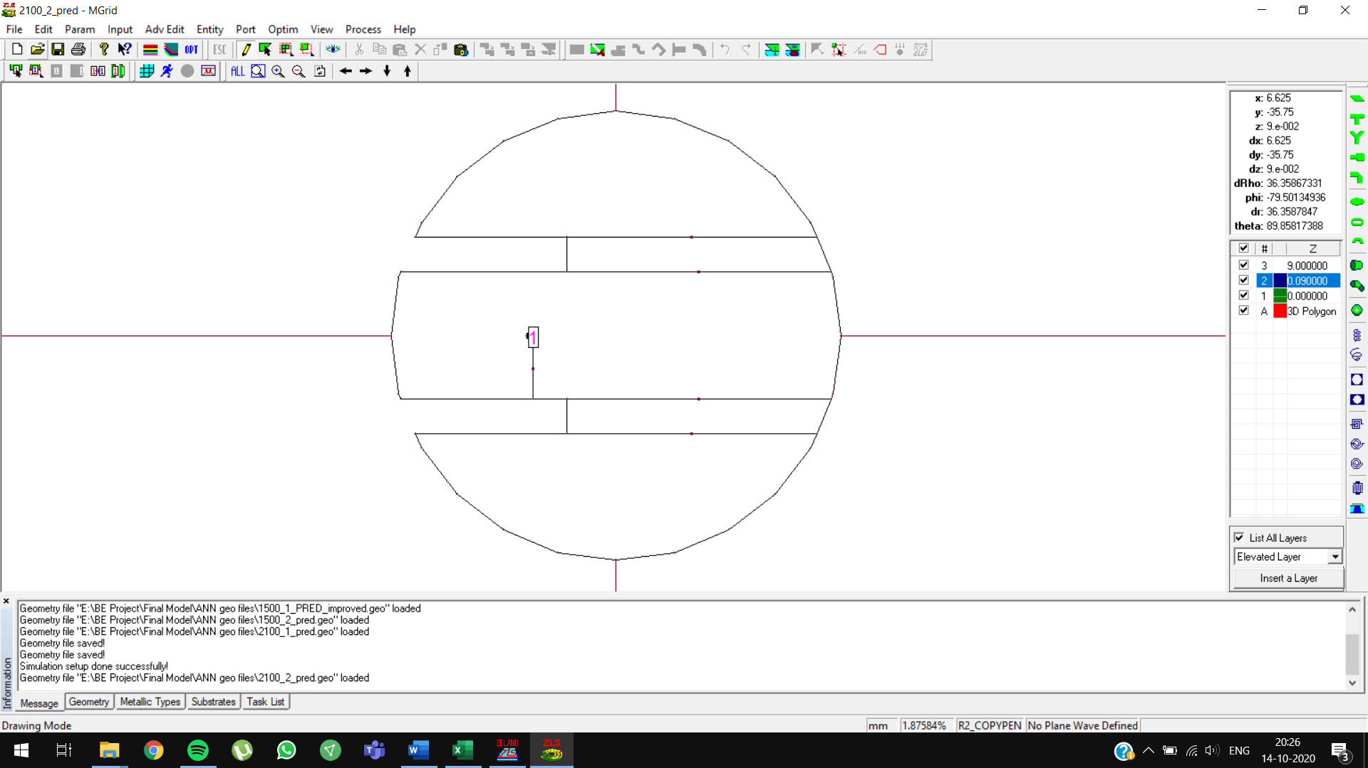

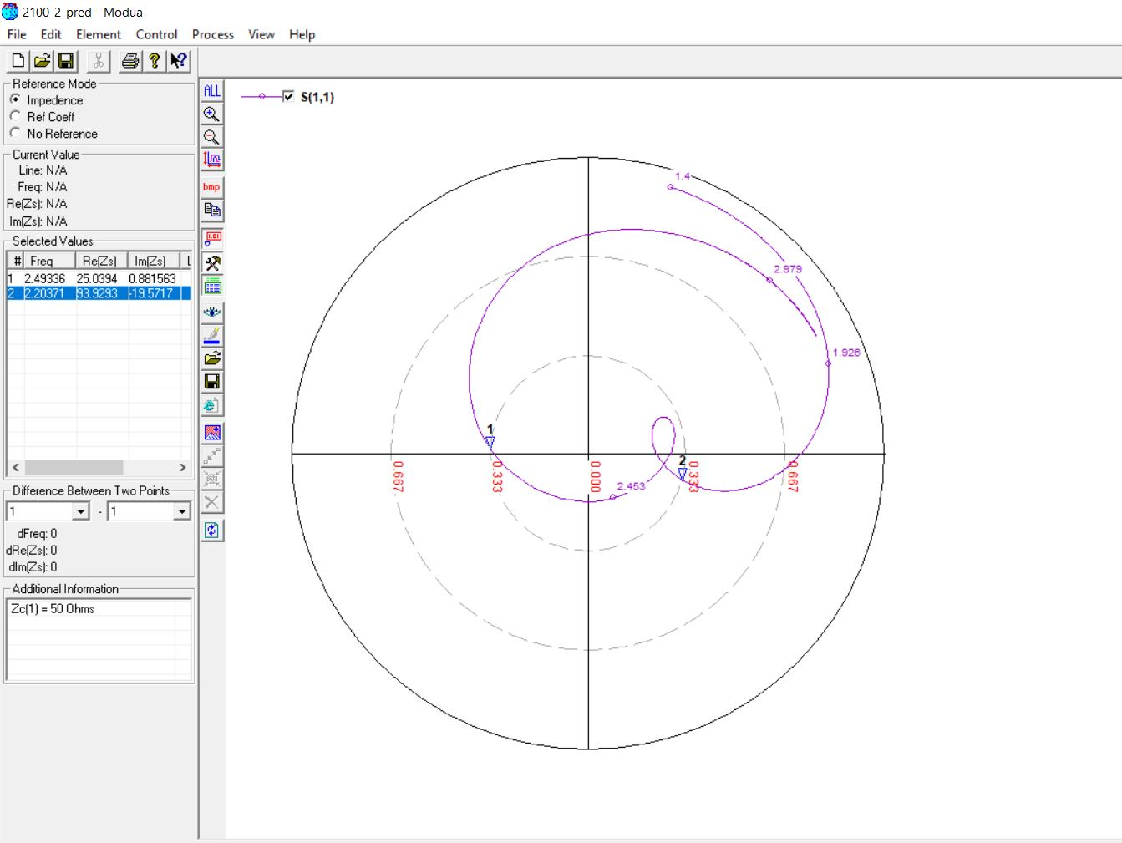

**2700 MHz, 6 (0.05 lambda)**

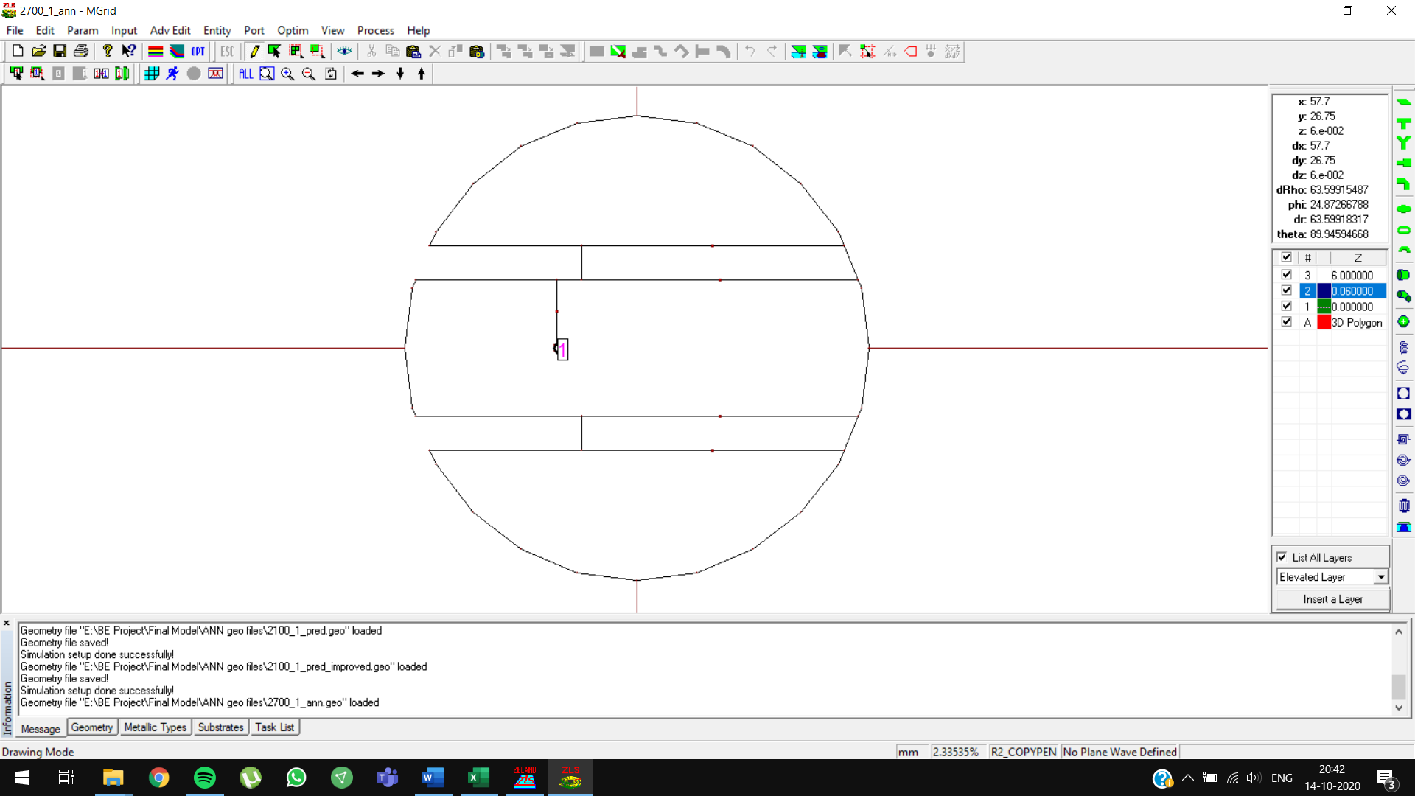

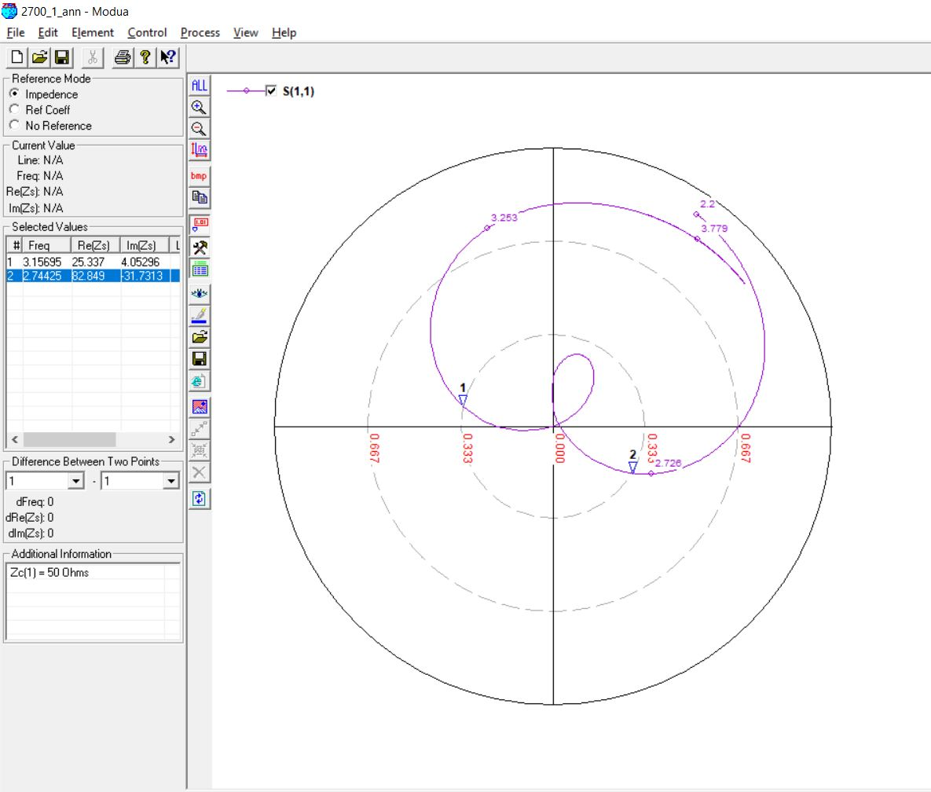

**2700 MHz, 7 (0.07 lambda)**

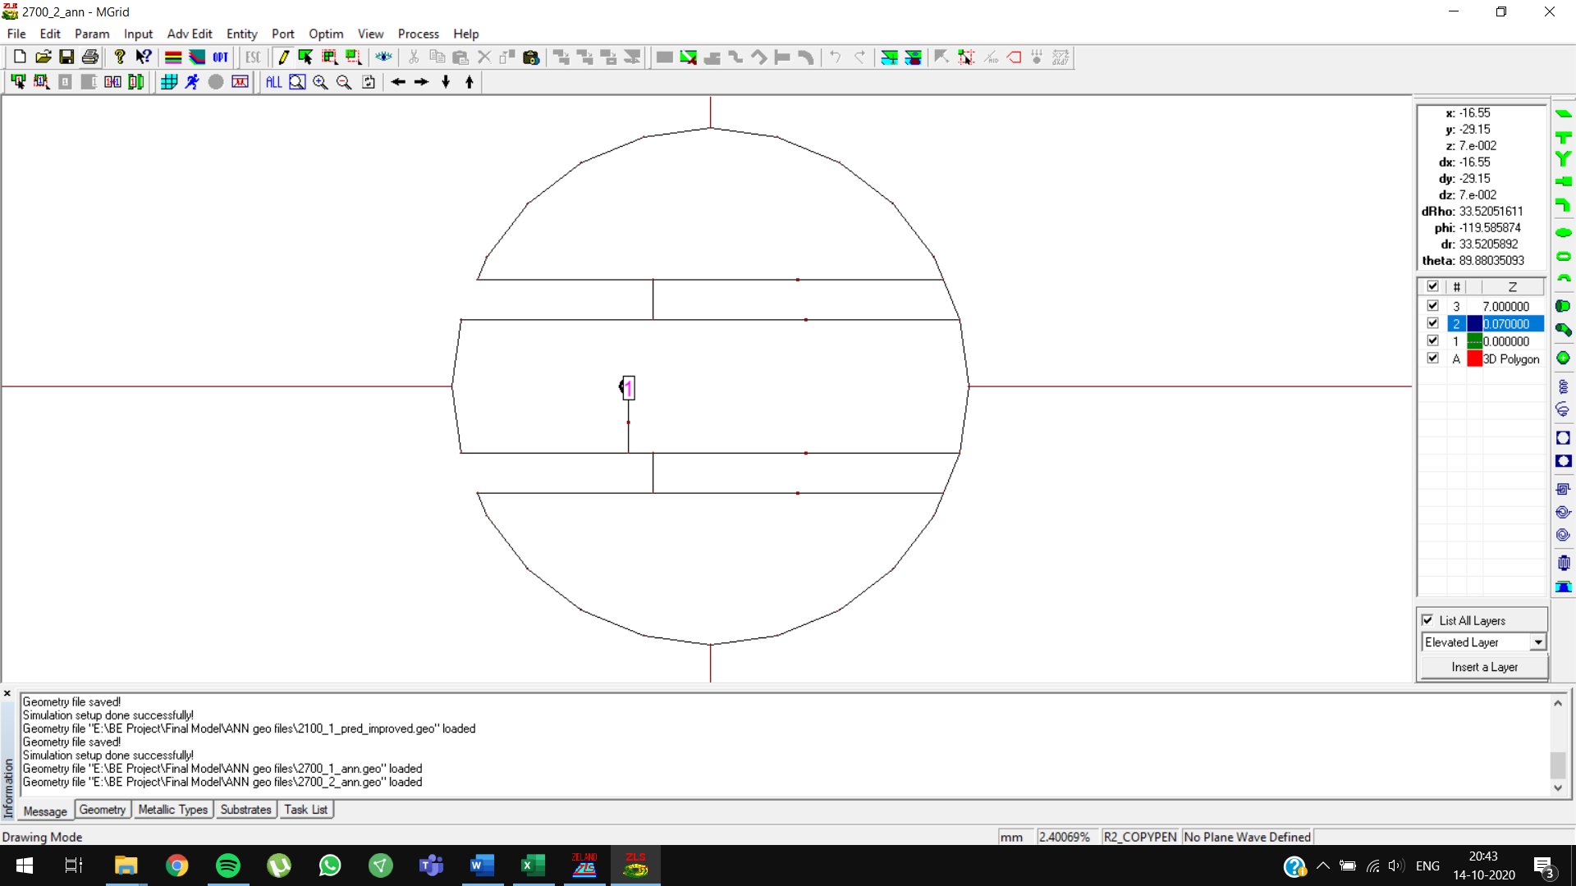

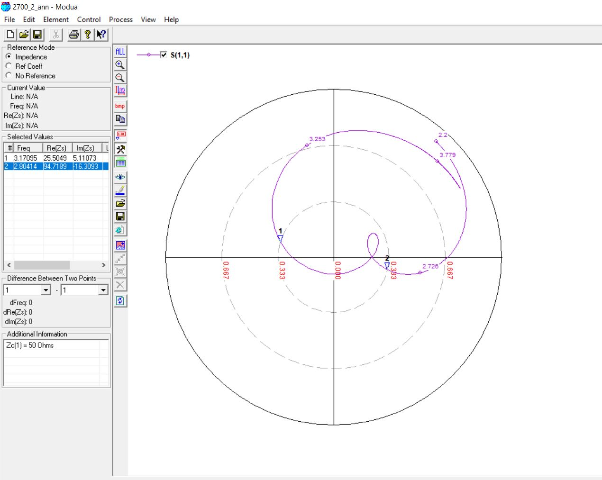

**3300 MHz, 5 (0.05 lambda)**

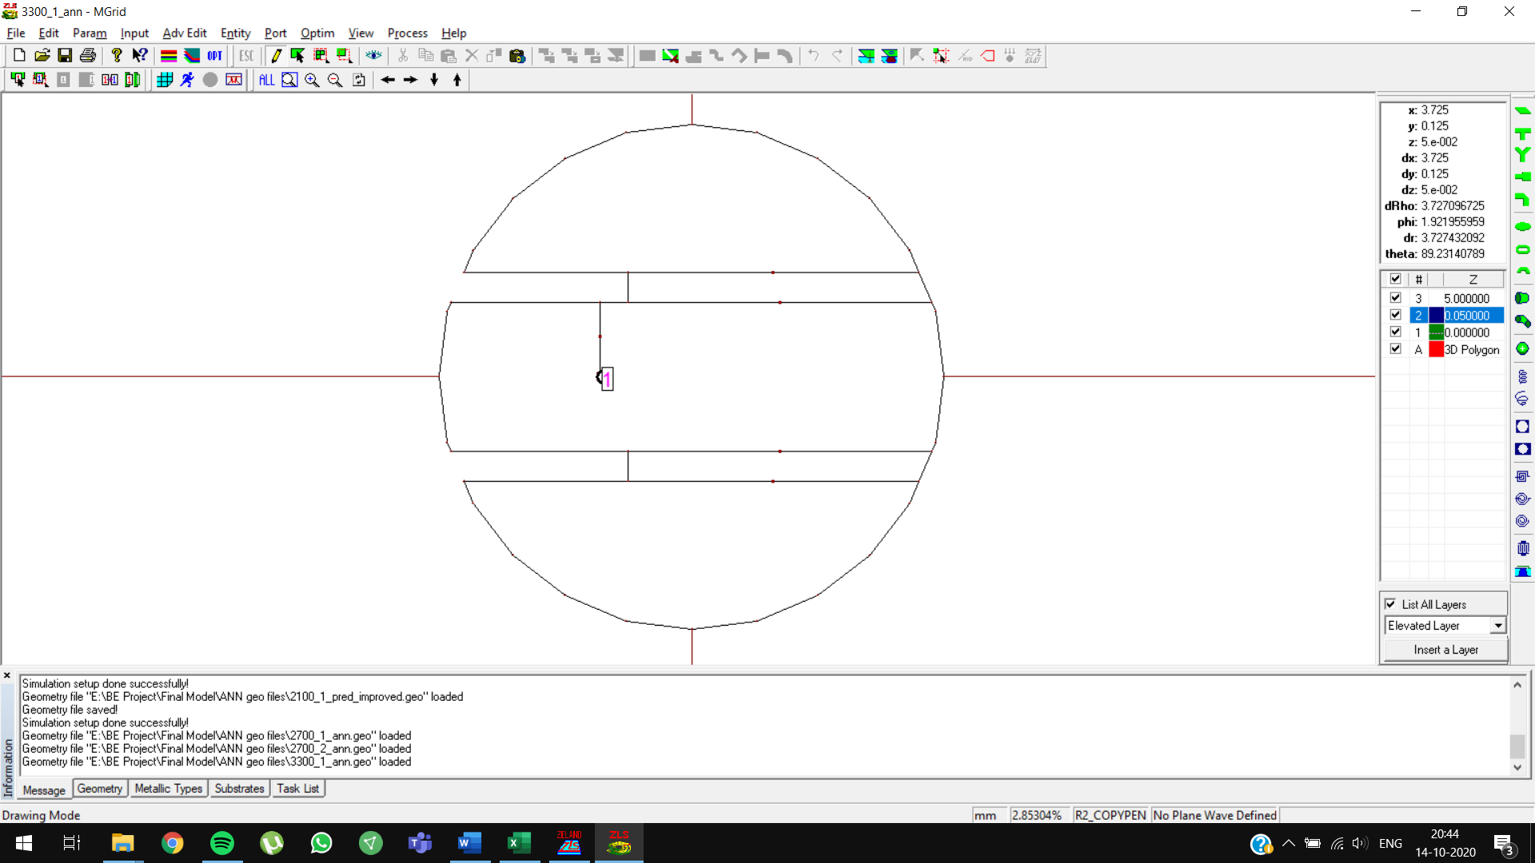

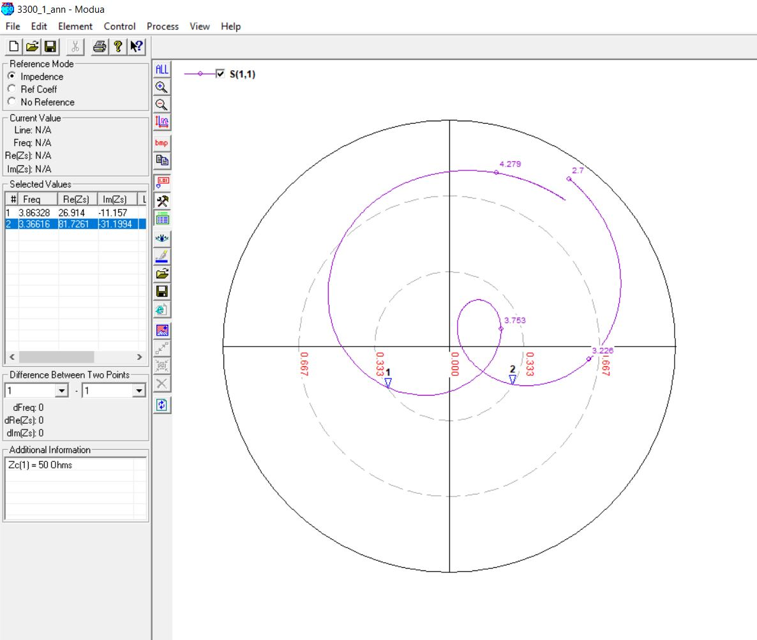

**3300 MHz, 6 (0.07 lambda)**

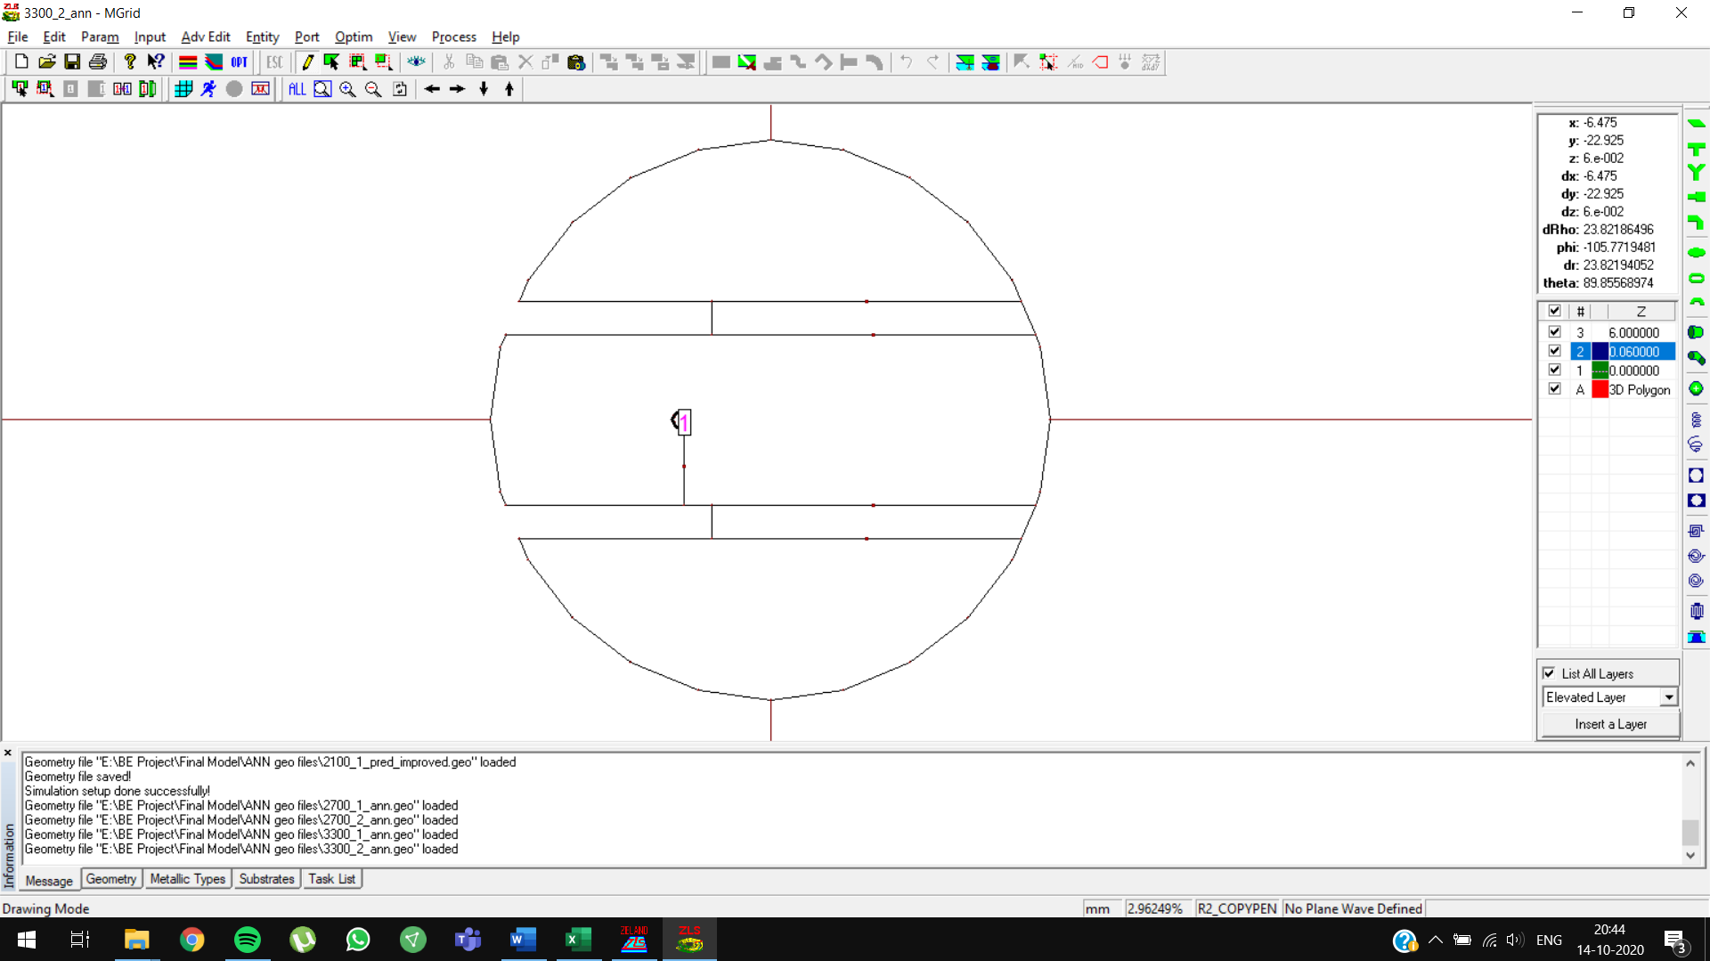

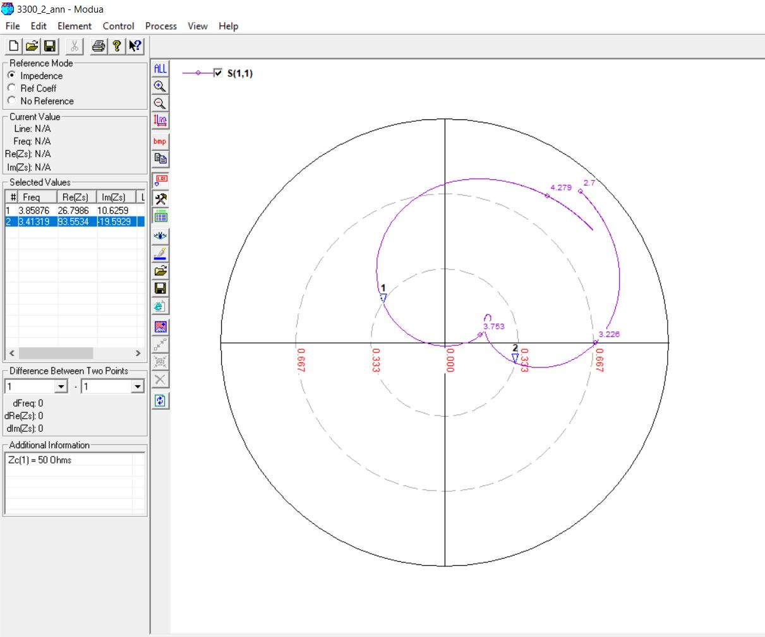

**3900 MHz, 5 (0.05 lambda)**

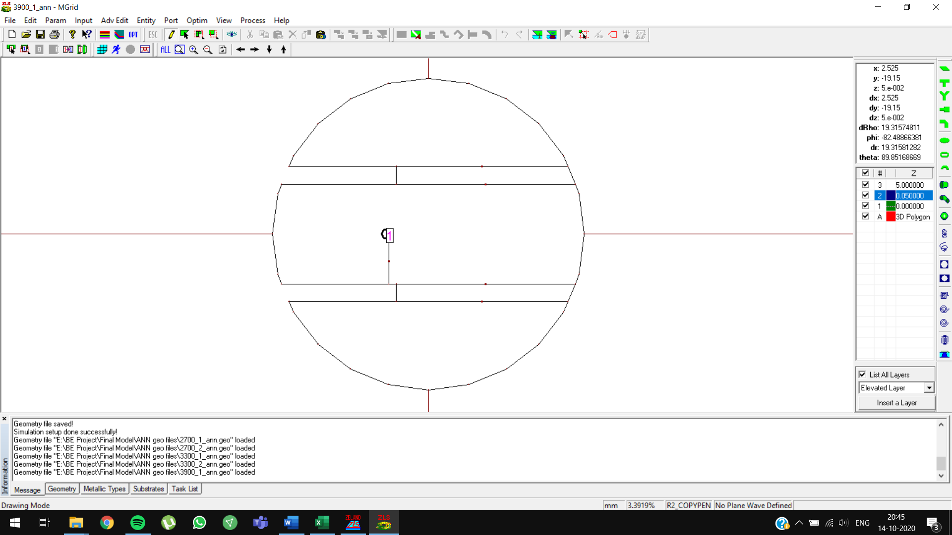

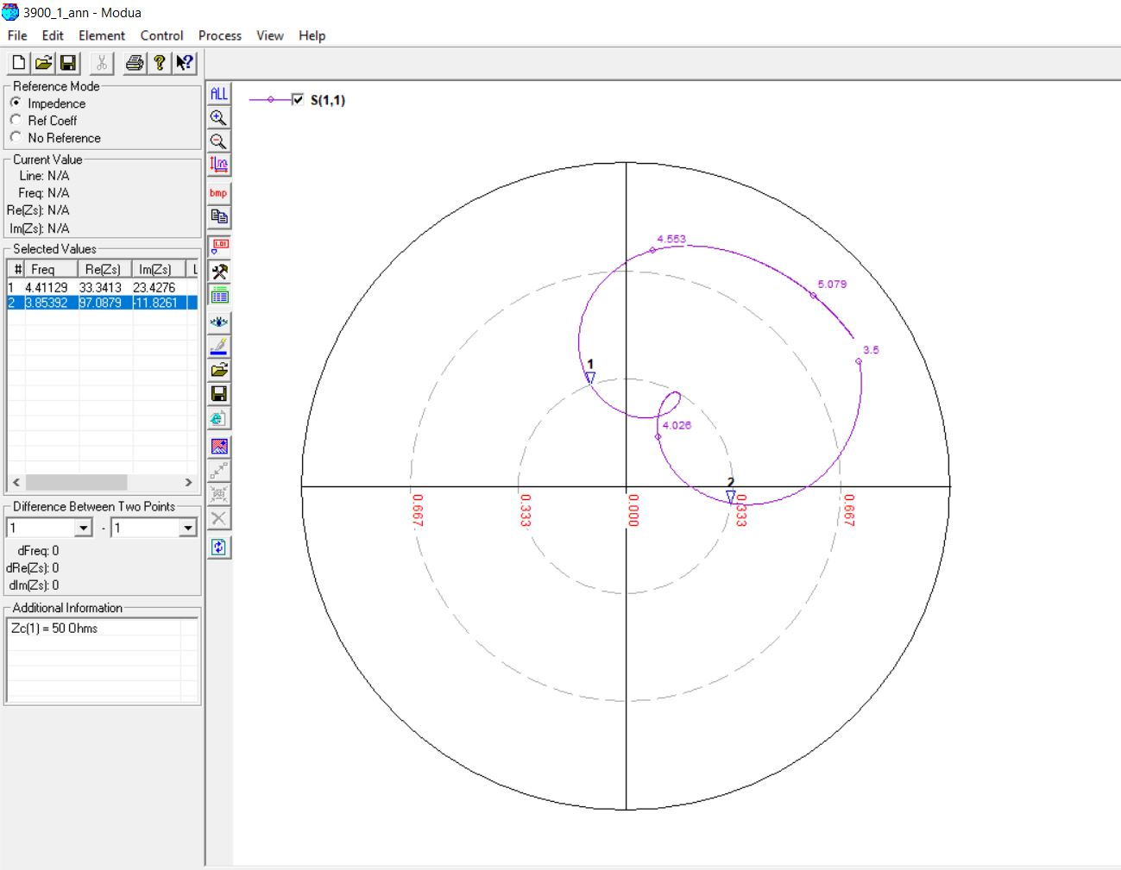

**3900 MHz, 5 (0.07 lambda)**

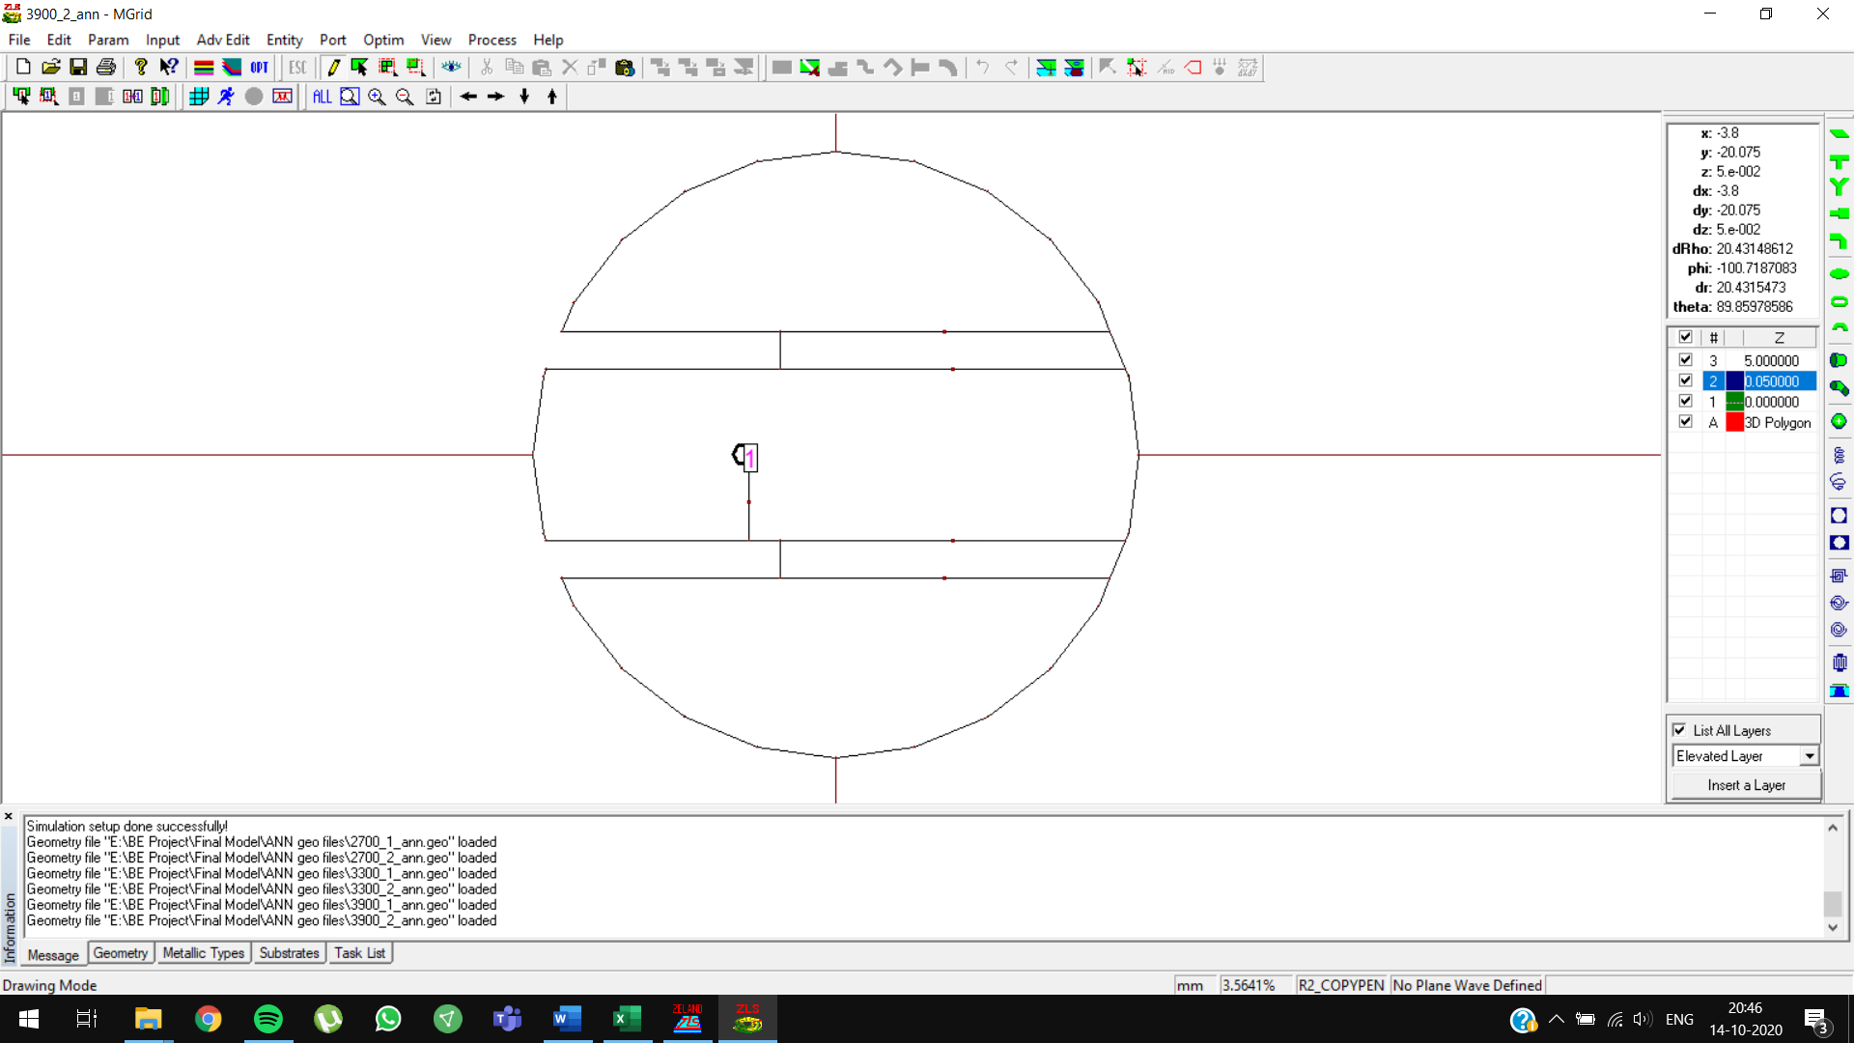

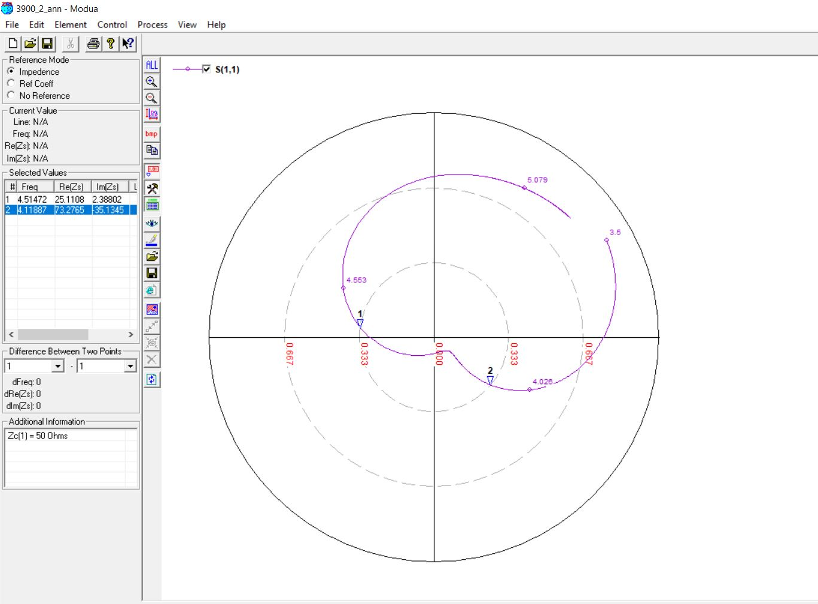

**4300 MHz, 4 (0.05 lambda)**

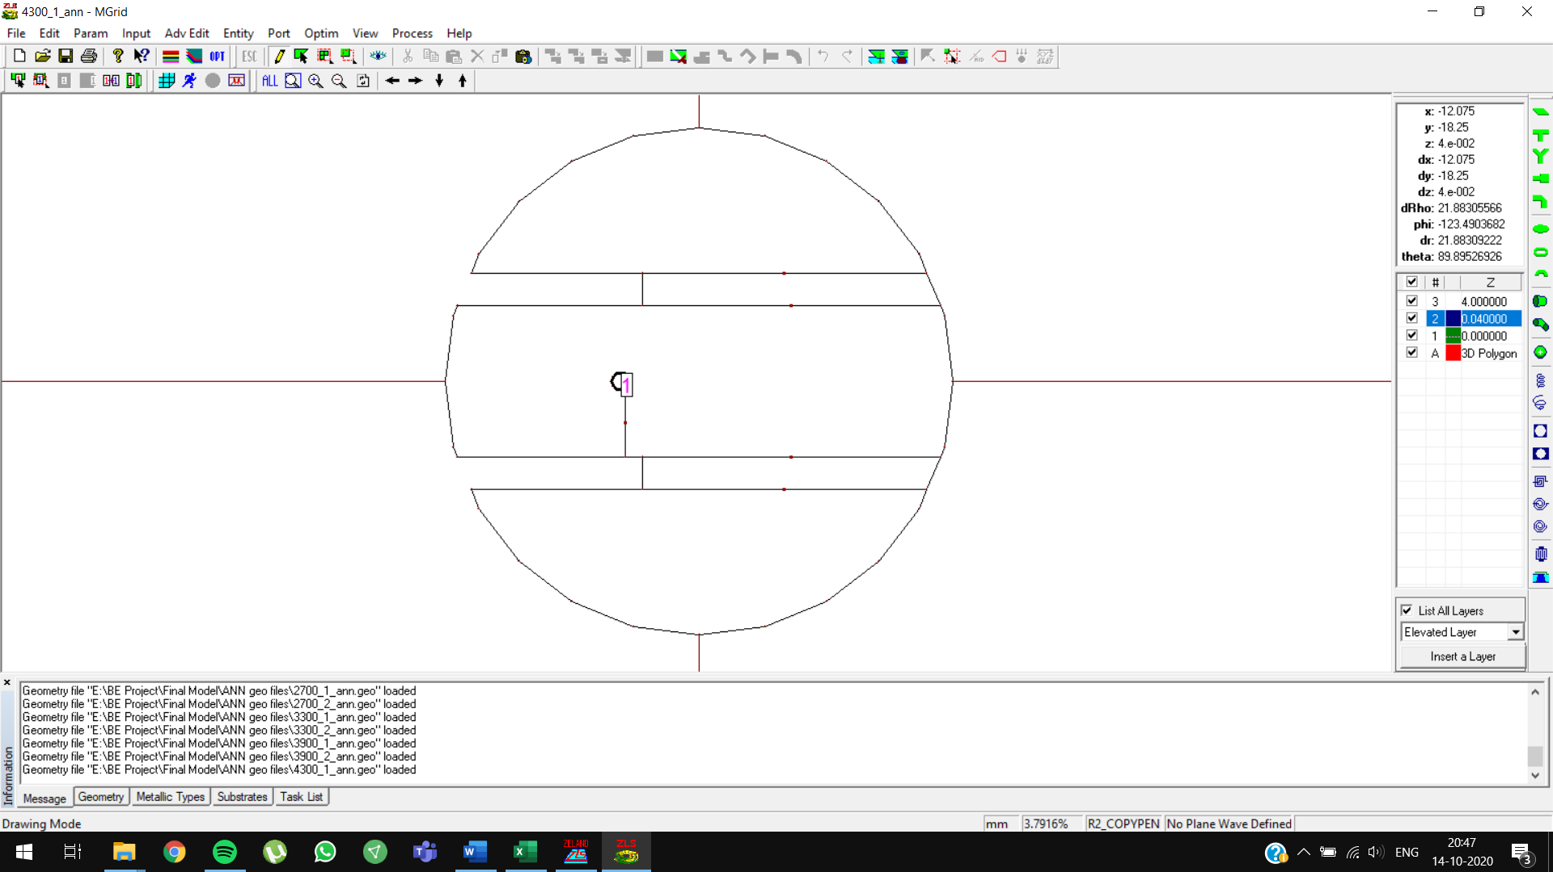

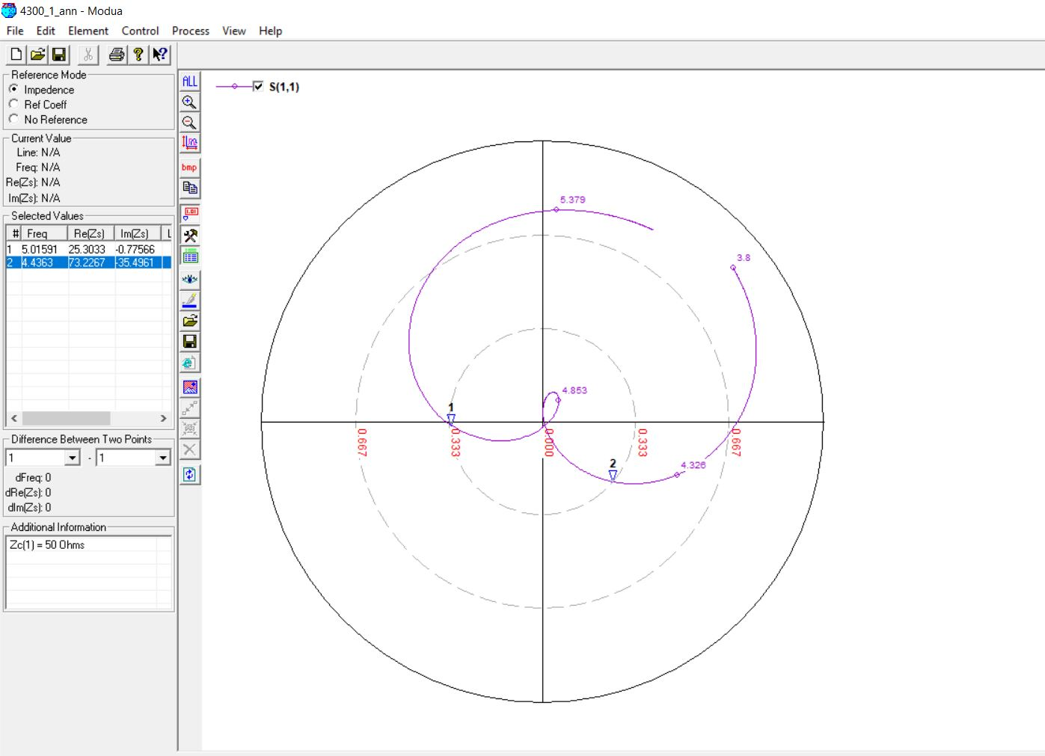

**4300 MHz, 4 (0.07 lambda)**

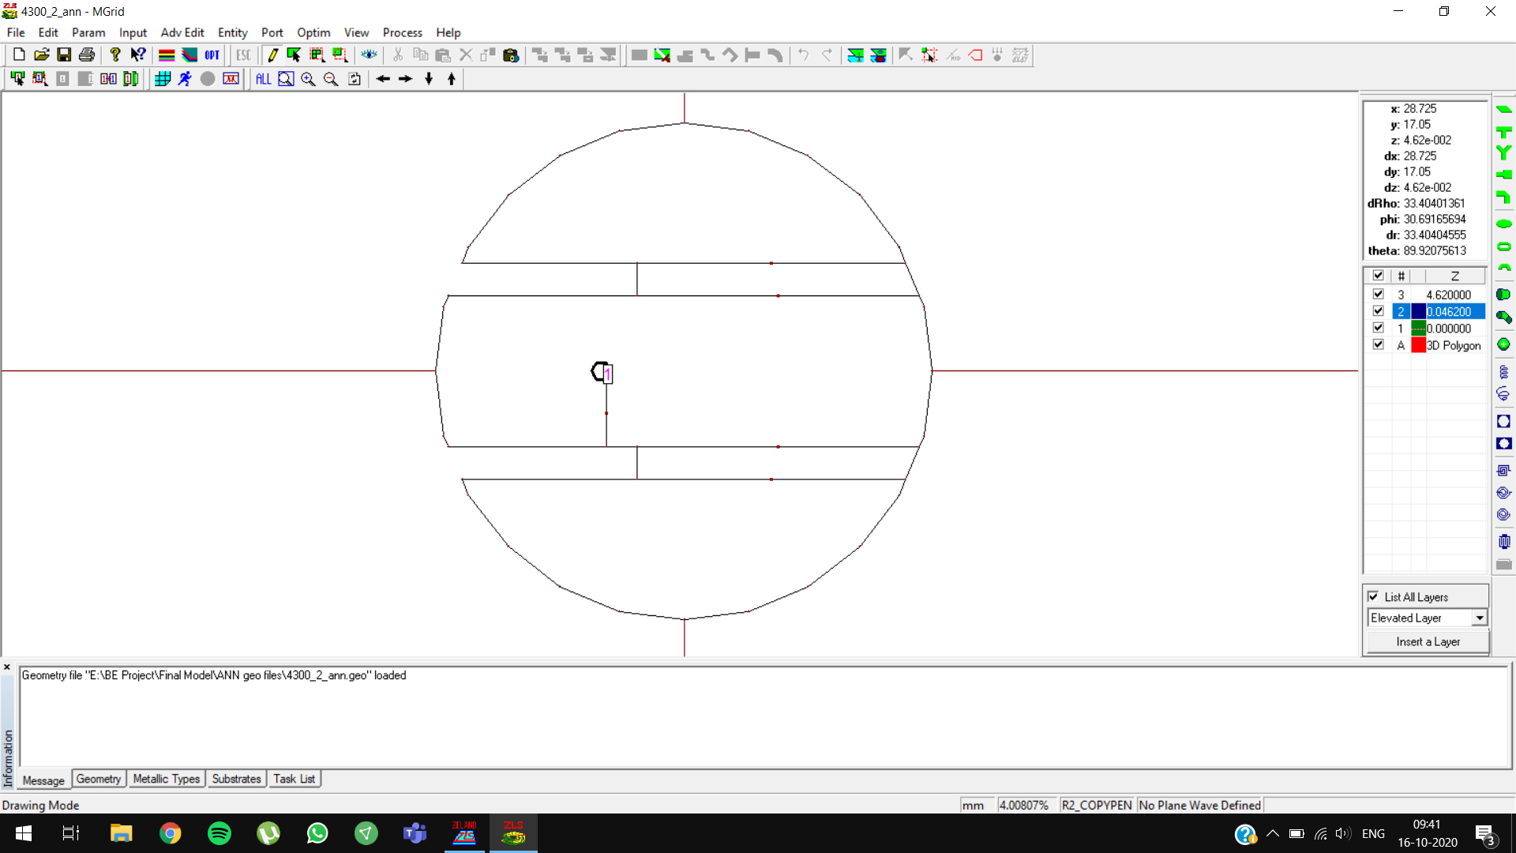

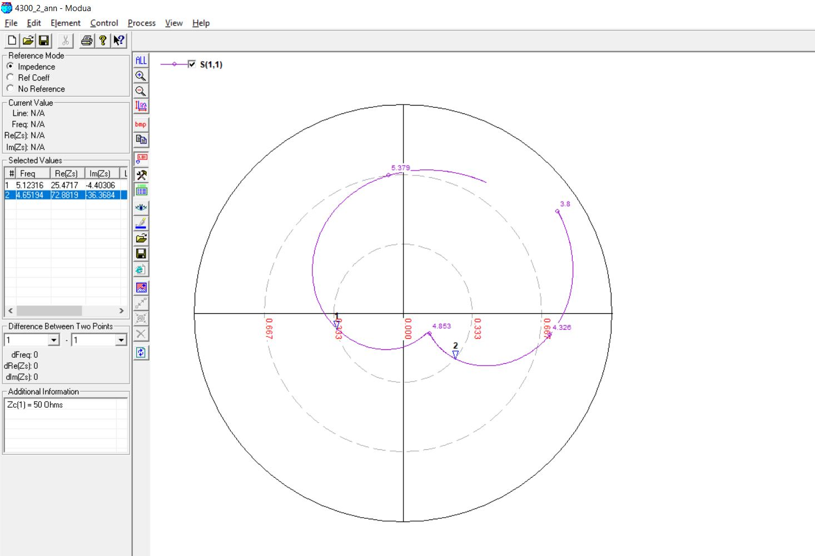

**4900 MHz, 4 (0.05 lambda)**

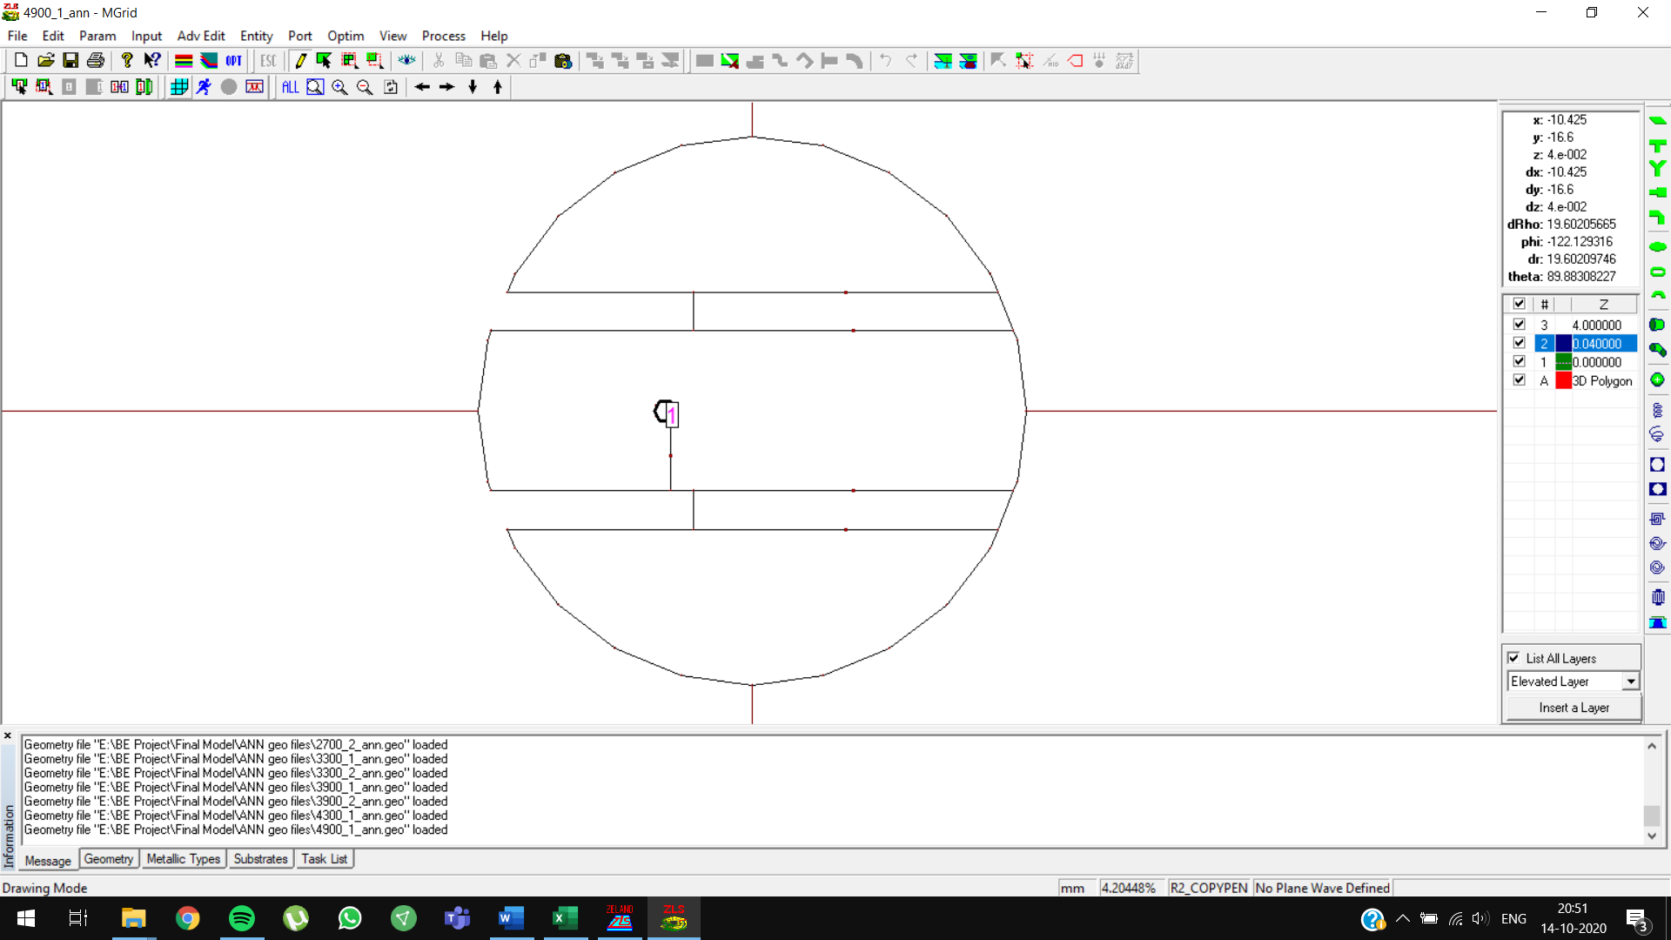

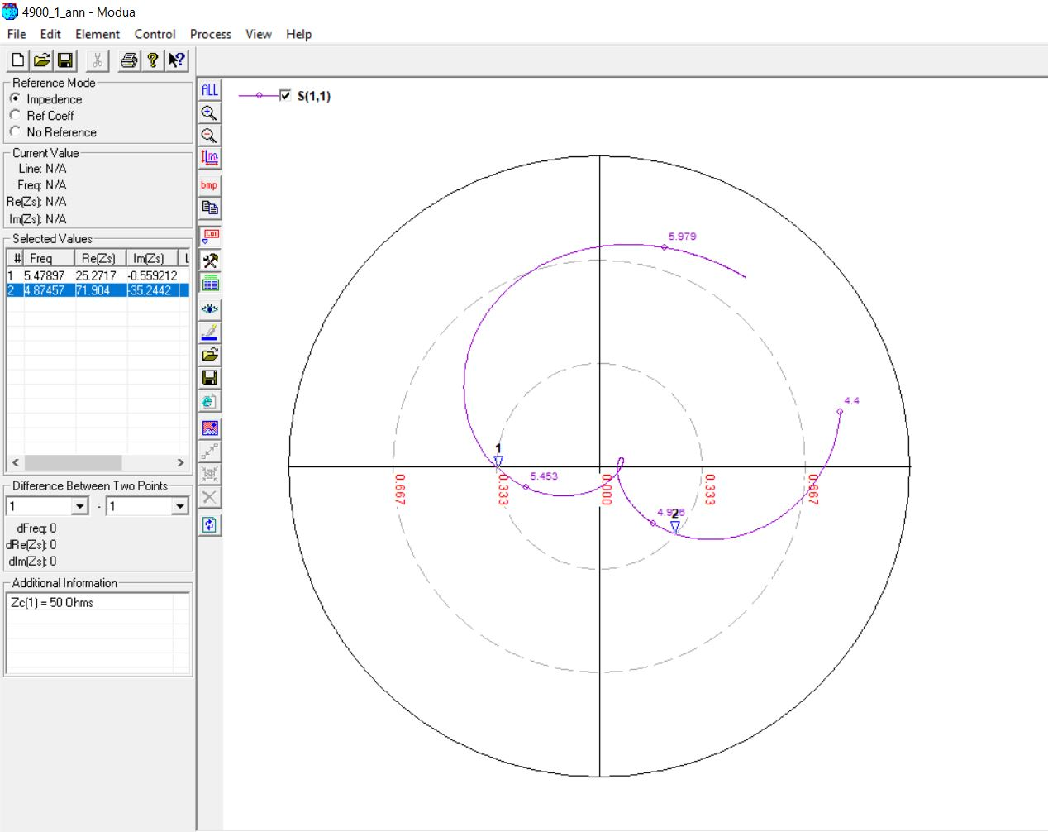

**4900 MHz, 4 (0.07 lambda)**

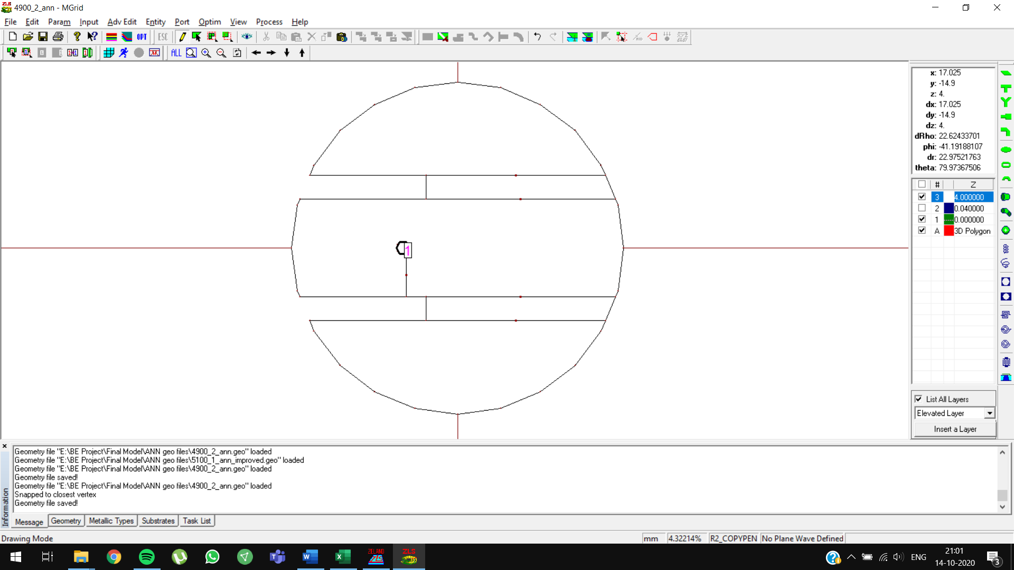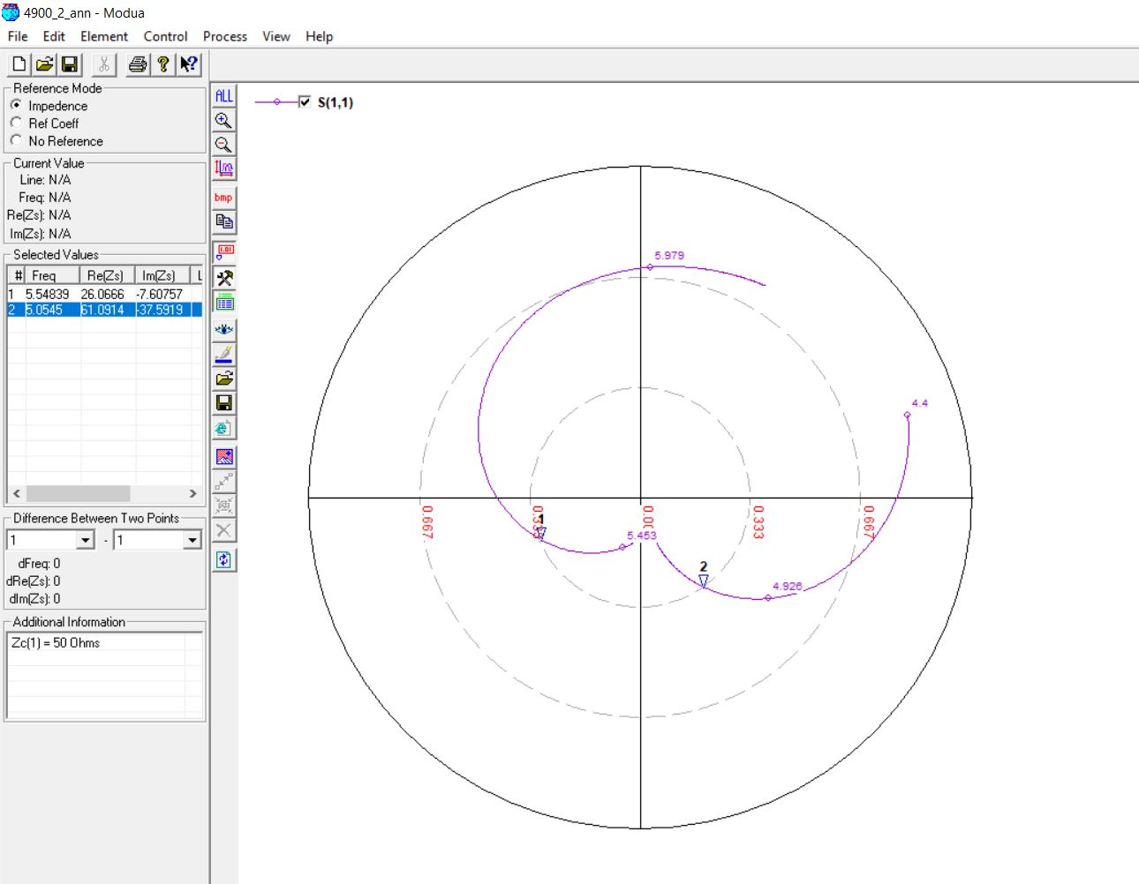

**4900 MHz, 4 (0.07 lambda) OPTIMIZED**

Initial Prediction: Slot length = **11.7882 mm**

Optimized Prediction: Slot length = **10.7882 mm**

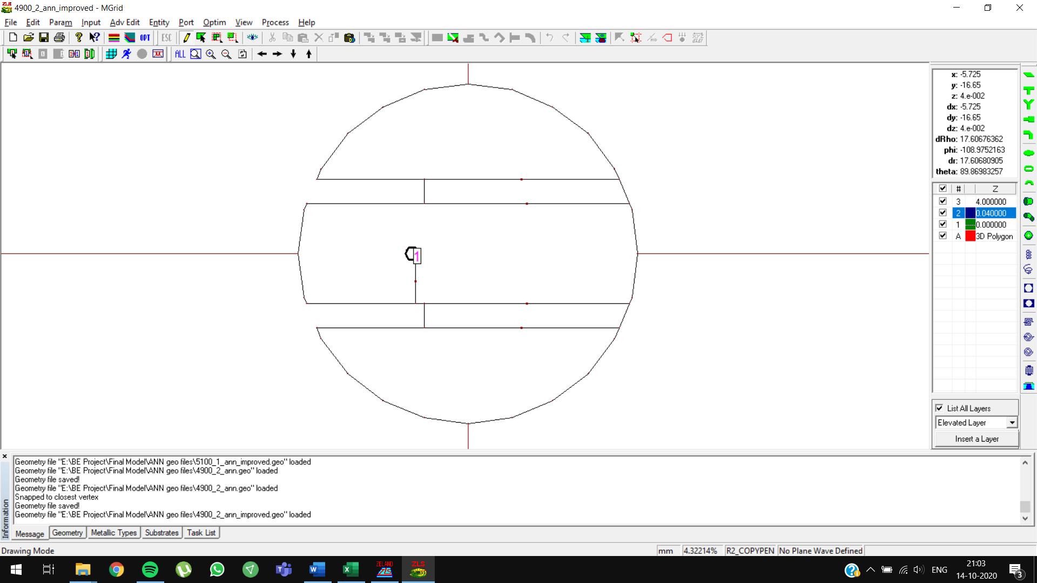

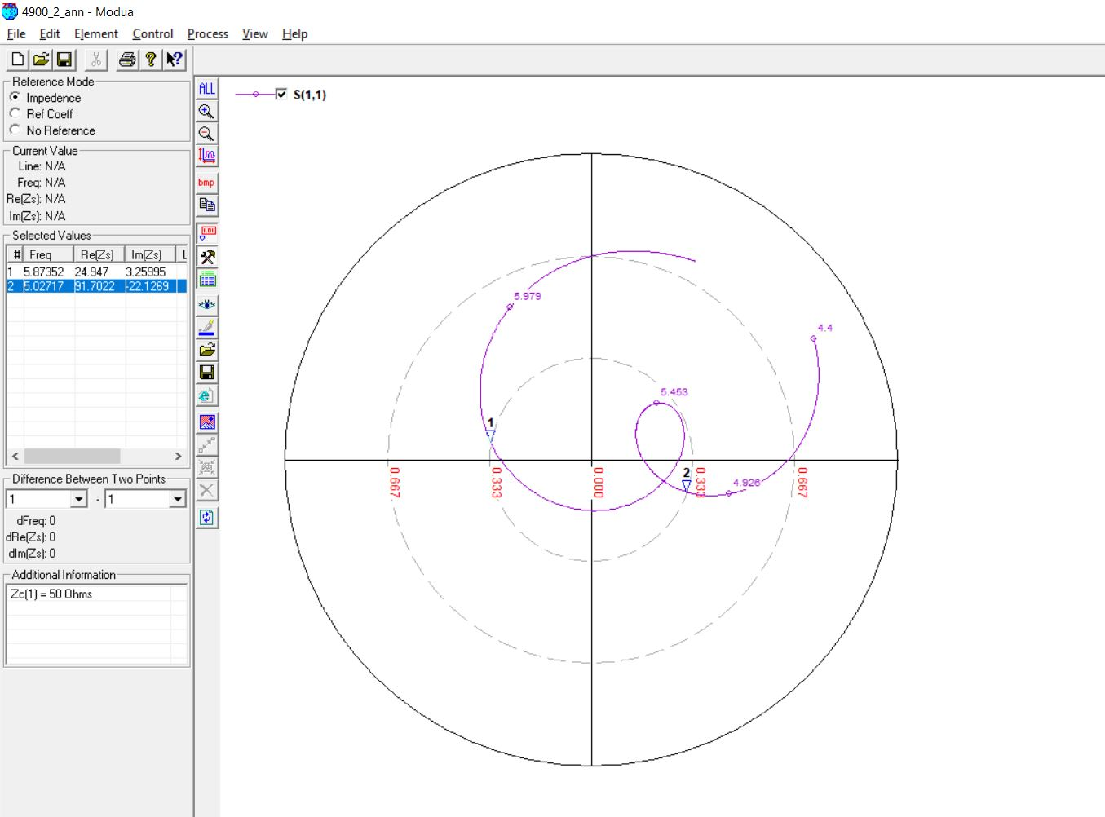

**5100 MHz, 4 (0.05 lambda)**

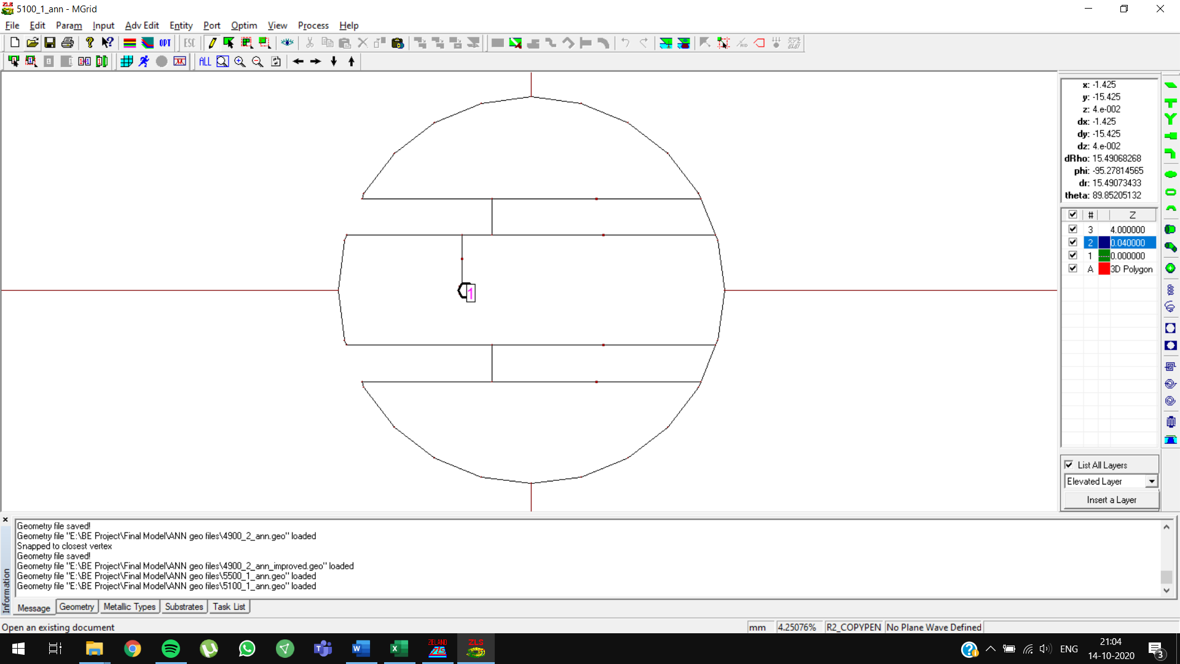

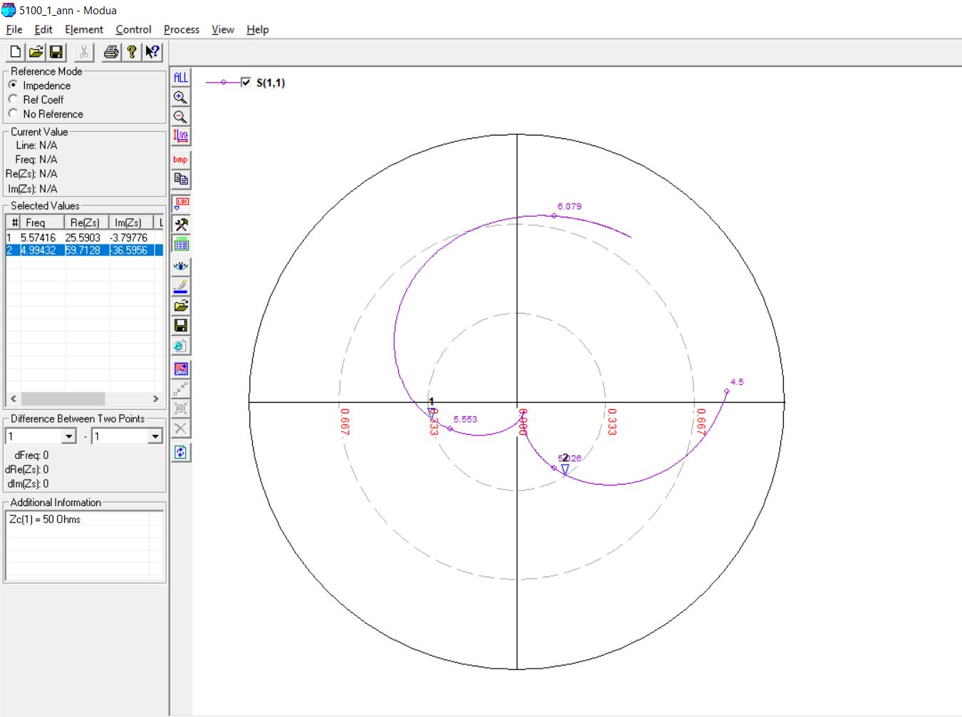

**5100 MHz, 4 (0.05 lambda) OPTIMIZED**

Initial Prediction: Slot length = **11.7498 mm**

Optimized Prediction: Slot length = **10.7498 mm**

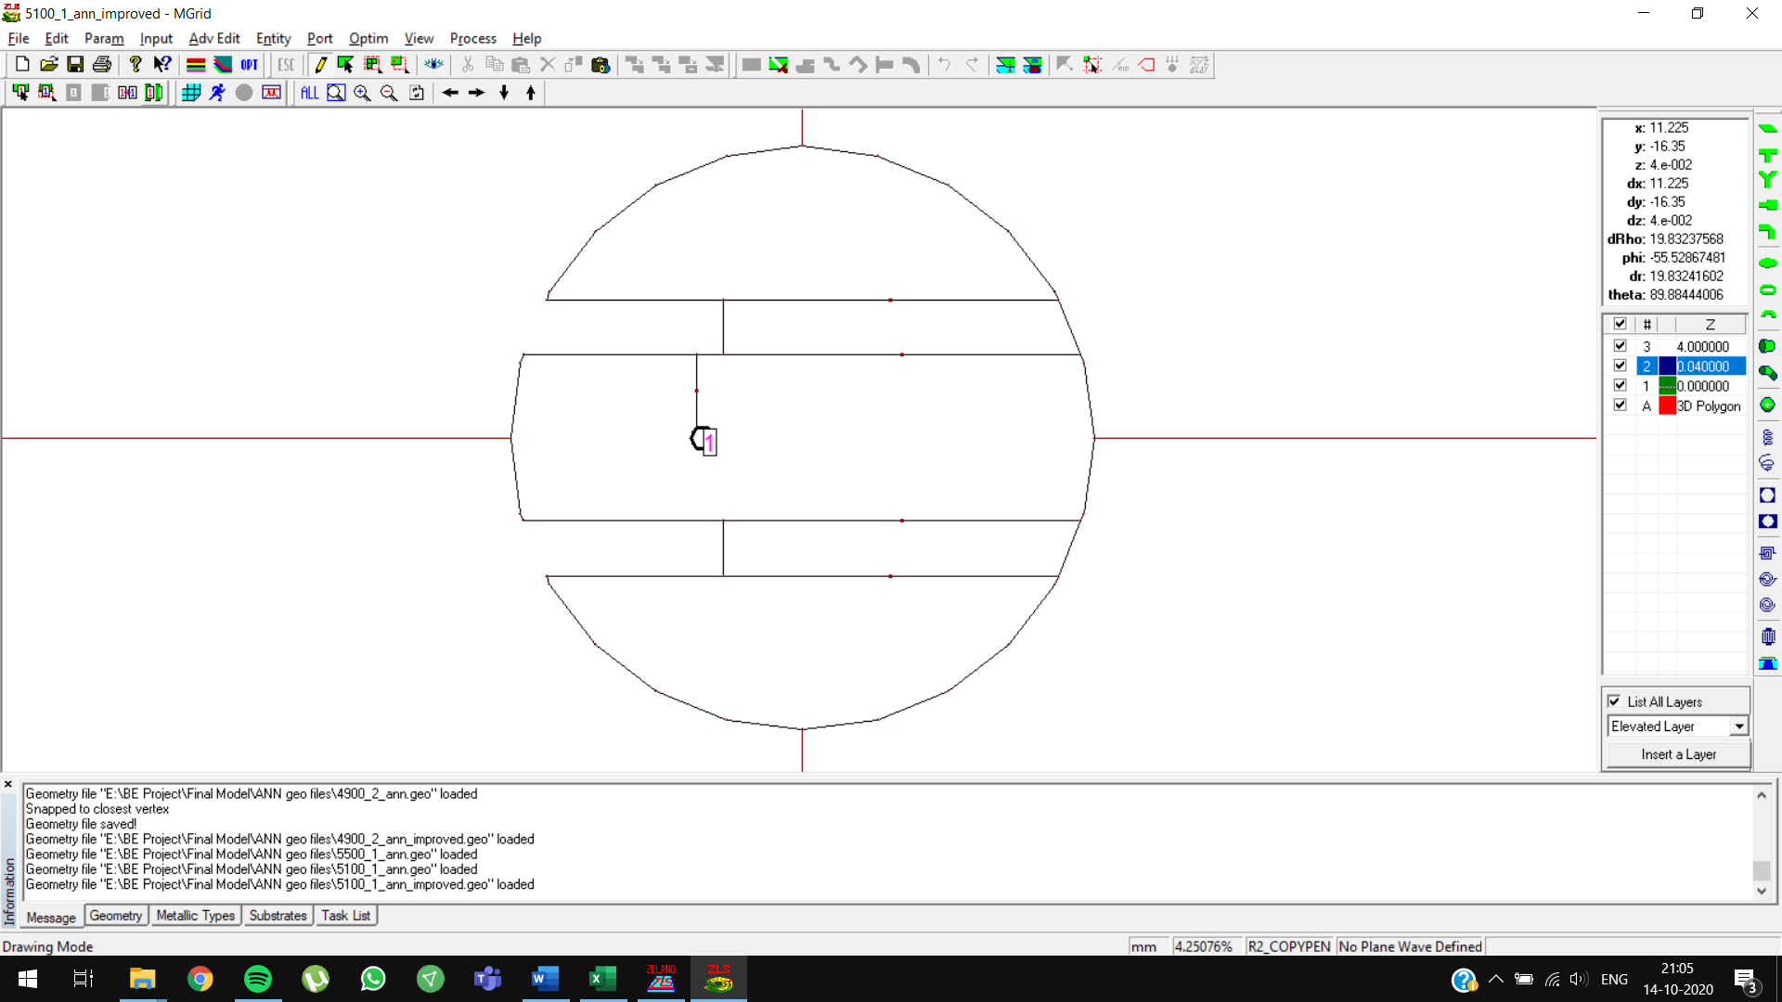

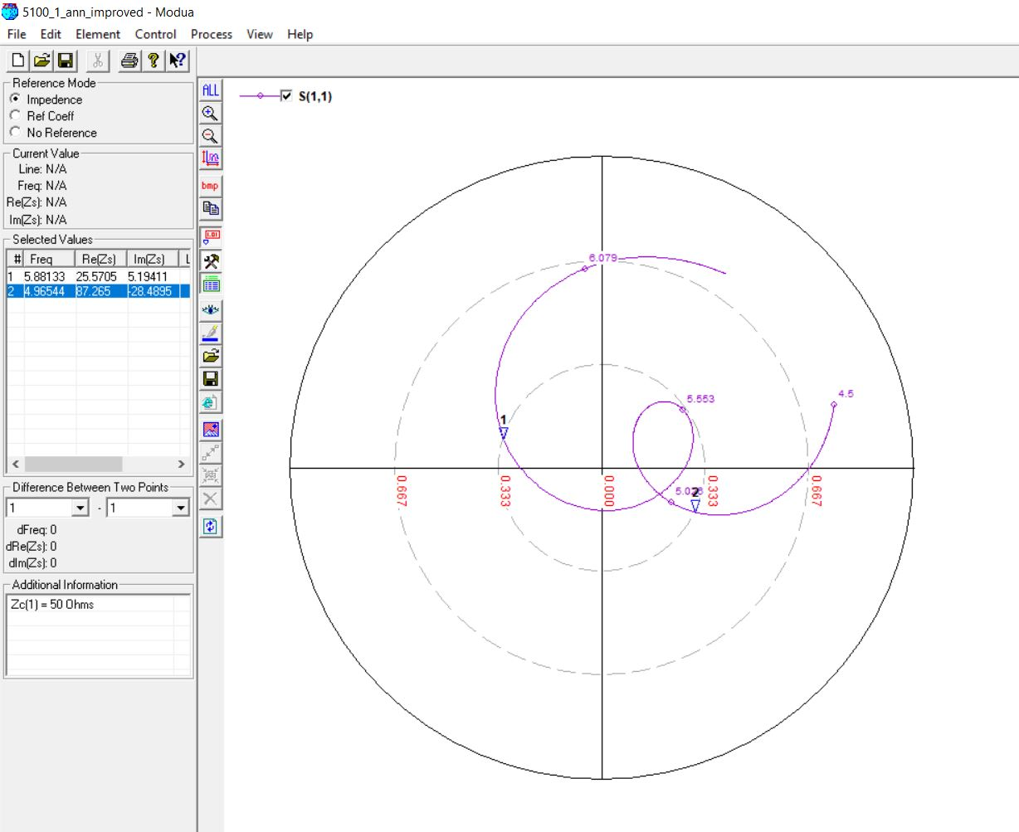

**5100 MHz, 4.5 (0.07 lambda)**

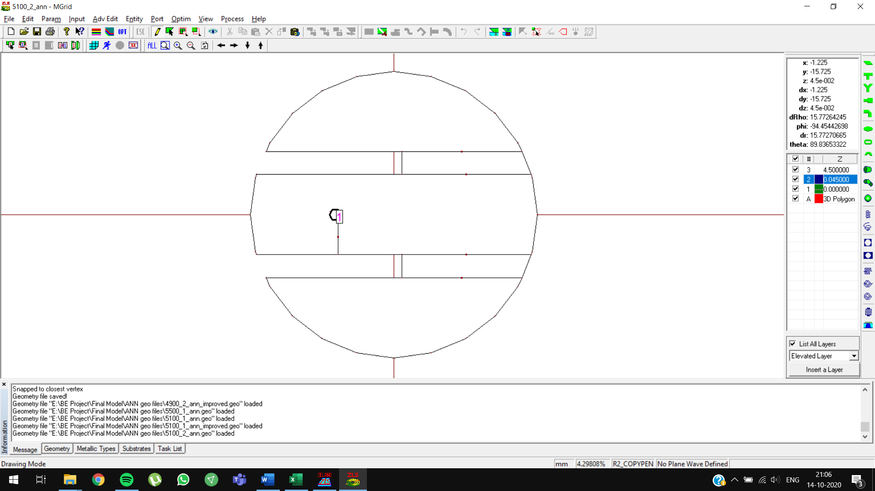

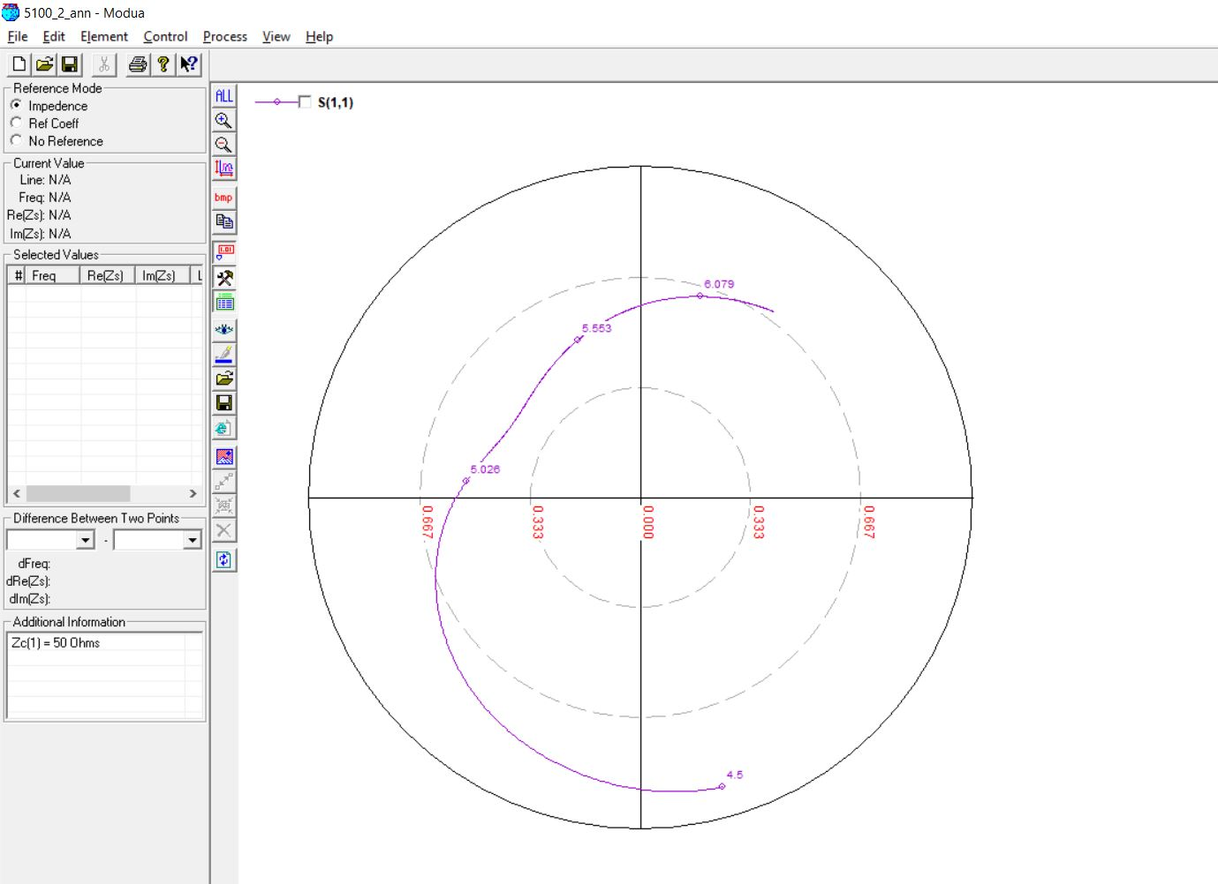

**5500 MHz, 4 (0.05 lambda)**

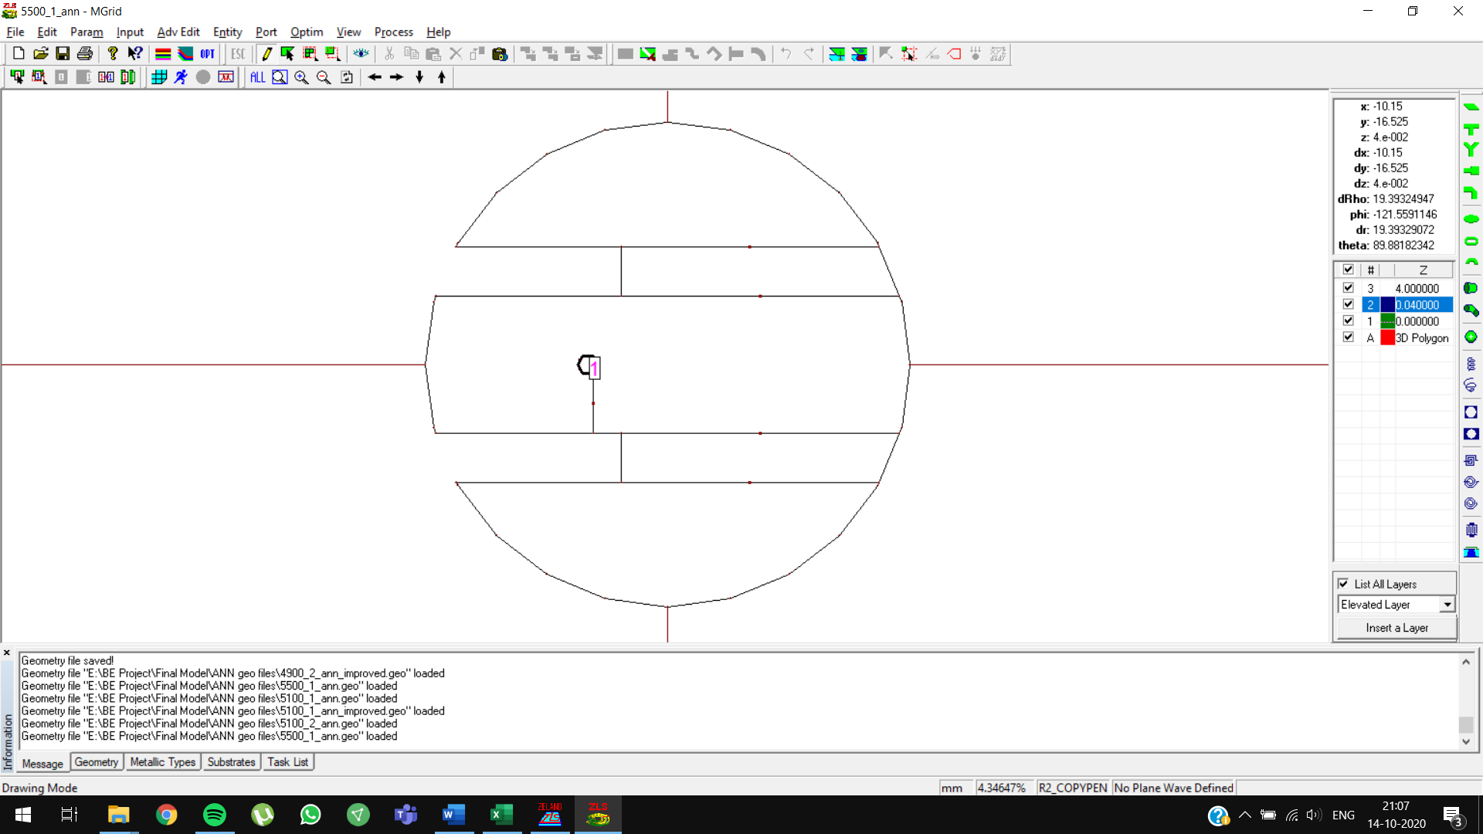

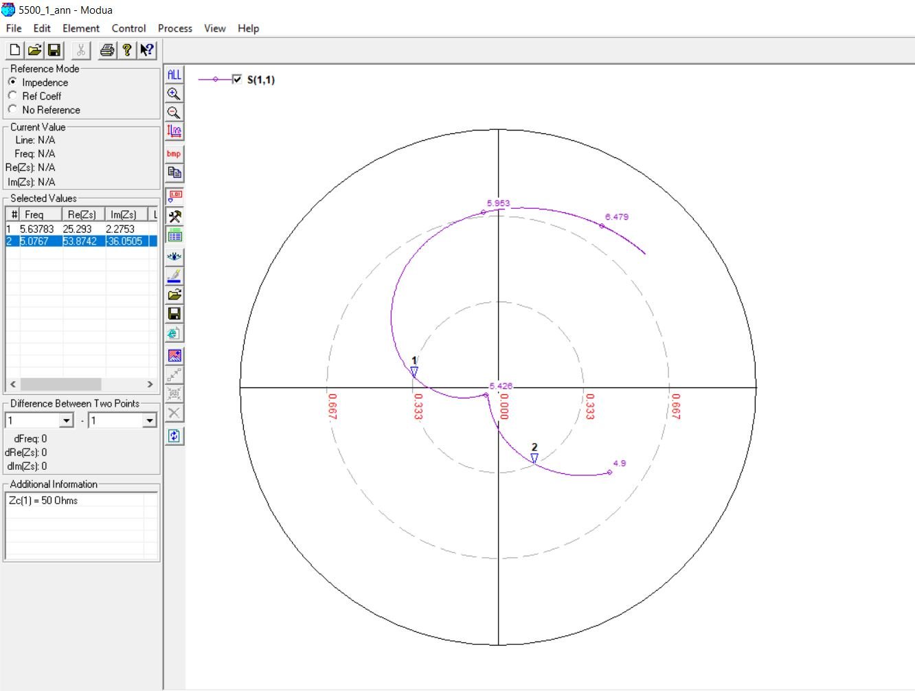

**5500 MHz, 4 (0.05 lambda) OPTIMIZED**

Initial Prediction: Slot length = **11.6569 mm**

Optimized Prediction: Slot length = **10.6569 mm**

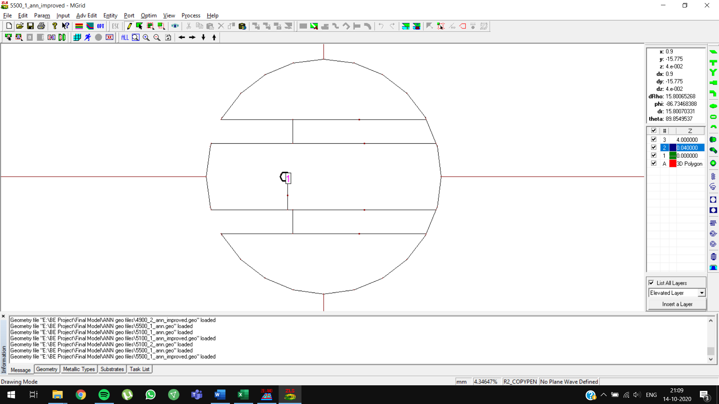

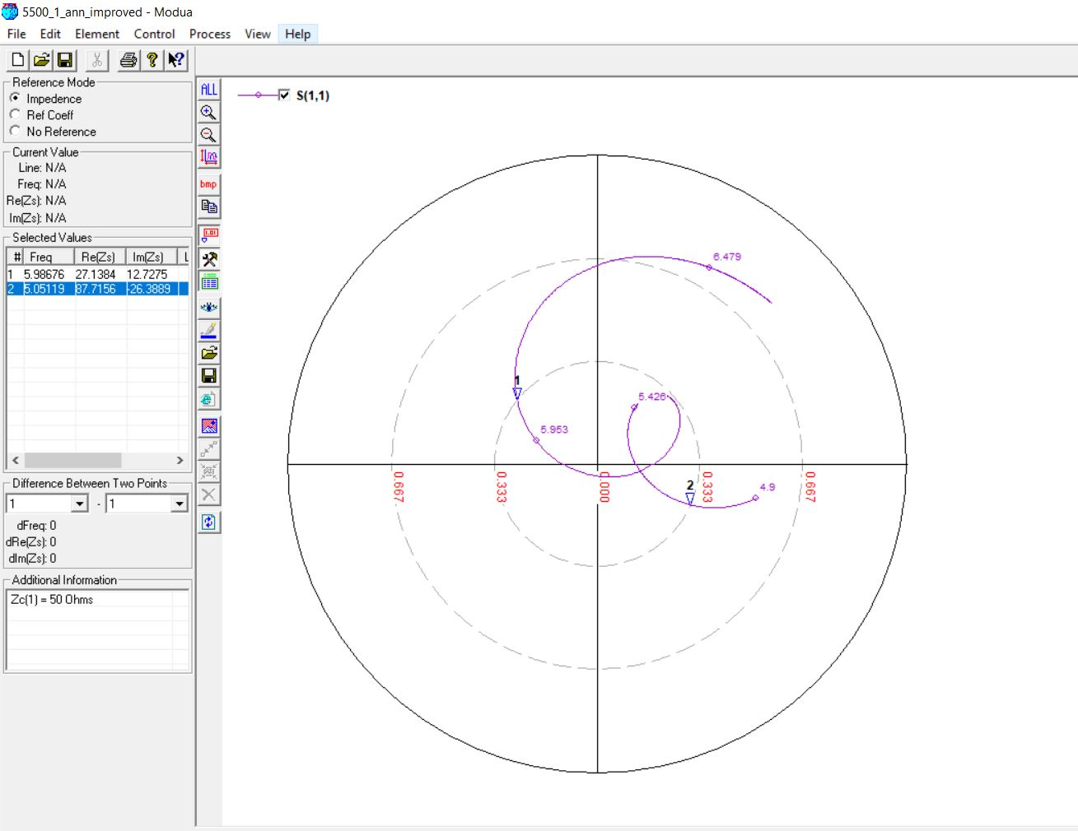

**5500 MHz, 4.5 (0.07 lambda)**

